THEME
Possession 6v3 into 6v3 with Transition to Defend

DESCRIPTION OF PRACTICE (TECHNIQUE / SKILL)
A Practice designed to improve players passing, movement, awareness, decision making and transition to defend
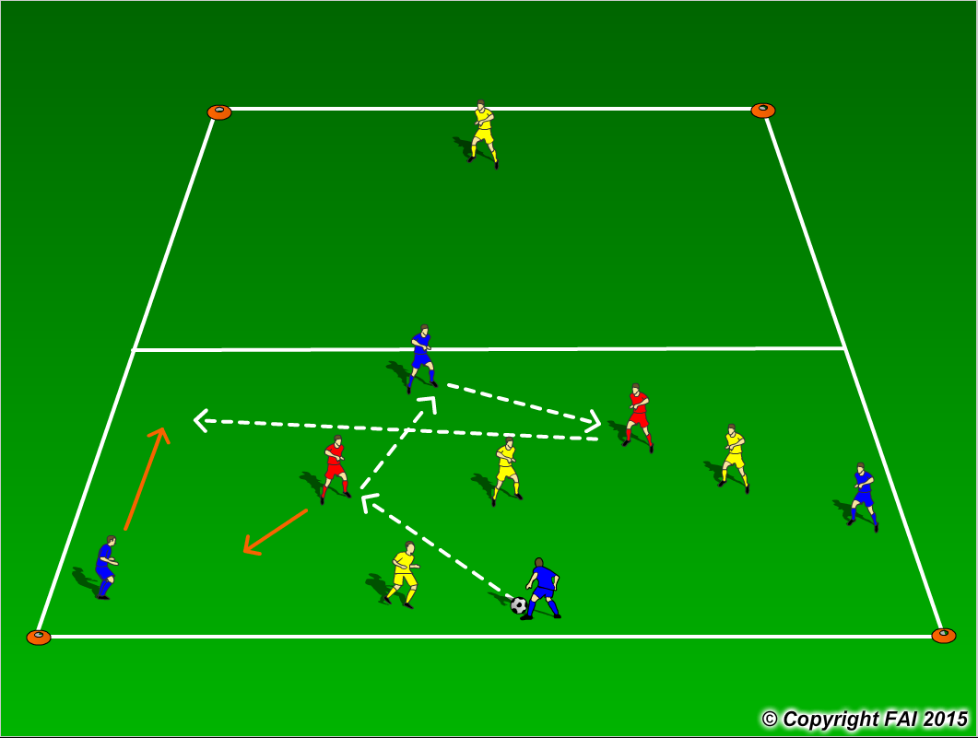
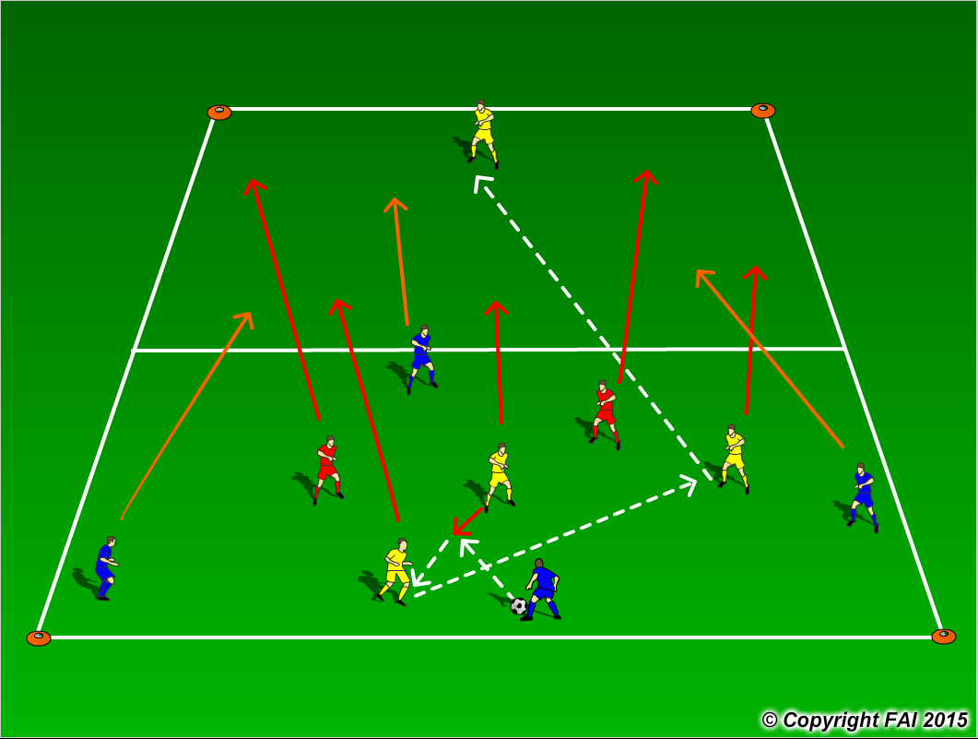

ORGANISATION
- Area: 40x30 metres
- Zone 1 – 4 Blues v 3 Yellows + 2 Reds (neutral players)
- Blue Team start the practice with the emphasis on keeping possession with Red players playing with the team in possession as seen above in diagram 1.
- If Yellow team win possession they must transfer the ball into Zone 2 to their teammate and join him/her along with the 2 Red players while 3 Blue players transition to defend as seen above in diagram 2 with Yellows now keeping possession.
- Coach to have supply of football on the sideline to keep the practice constantly going, if team in possession knock the ball out of play the coach restarts the practice with the opposite team.
- Quick transition in both Attack/Defense

KEY FACTORS
- Quality and selection of pass – Back Foot
- Weight, accuracy and height of pass
- First touch/Body shape
- Angles and Distance of support
- Width and depth – Penetrating Pass
- Awareness of space
- Communication
- Transition to Defend – can we win ball back as quickly as possible

NOTES
Demand high intensity (3 minutes playing time, 1 minute rest). If players of a high ability play two touch.

