THEME
Possession 3 v 1 with Target

DESCRIPTION OF PRACTICE (TECHNIQUE / SKILL)
A functional practice designed to improve players passing and movement and transition to defending

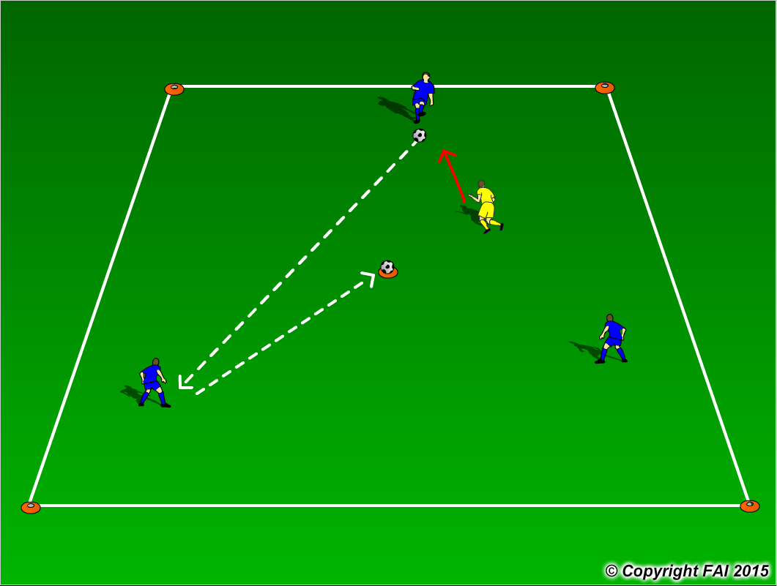

ORGANISATION
- Area: 12 x 12 metres
- 3 Blue Players v 1 Yellow Player
- 1 Ball placed on top of cone in the middle of area
- Blue Players start with possession and try and keep ball from the Yellow Player
- The Yellow Player must try and win the ball but also stop blue players from knocking ball of the cone in the middle of the area
- The Blue players must pass the ball until an opportunity arises to knock the ball of the cone in the middle of the area
- If the Yellow Player wins the ball, he/she must try and dribble outside the area
- The player that made the mistake then goes into the middle

KEY FACTORS
- Quality and selection of pass
- Body shape/Receive on Back Foot /First Touch
- Disguise/Change of Direction
- Angles and Distance of support
- Awareness of space and defender
- Transition to Defend – can we win ball back as quickly as possible

NOTES
If players of a high ability encourage two touch. Can play a game to see who can knock the ball of the cone the most times

