THEME
3 + 2 v 3 + 2 Dribbling, Running with the Ball and Combinations

DESCRIPTION OF PRACTICE (TECHNIQUE / SKILL)
A functional practice designed to improve players decision making in a high intensity game through dribbling, running with the ball or combinations

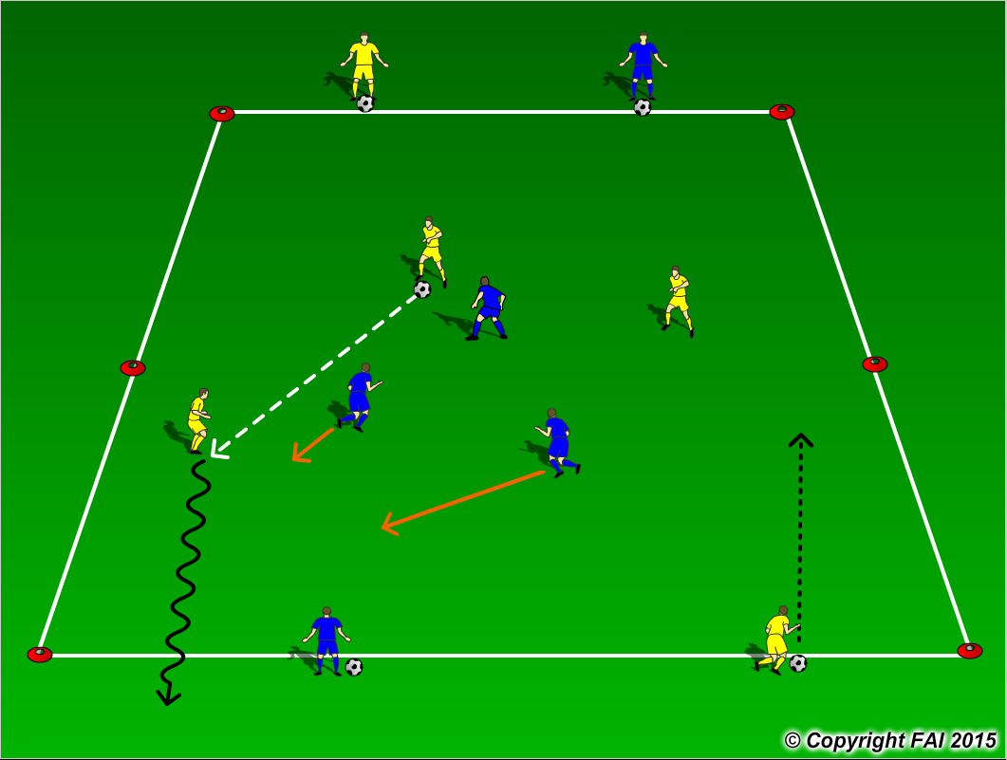

ORGANISATION
- Area 30 x 20 metres
- 3 Blue Players v 3 Yellow Players in the area, with 1 Yellow Player and 1 Blue Player on each end
- The Players score by dribbling over the end line with the ball under control, once a player dribbles over the line, the end line player of same colour is allowed to join in and attempt to dribble over the opposite end line as seen by Yellow Players in the diagram
- If the team out of possession wins the ball they must attack the opposite end line
- The Players on the end line can move along the line to take advantage of any space in anticipation of their player crossing over the line

KEY FACTORS
- Be decisive in all actions - movement, decision making, awareness and passing
- Know when to play 2 touch or 1 touch, Dribble or Run with the ball
- Combinations (Wall Pass, Over/Under laps, 3rd Man runs)
- Weight and accuracy of pass
- Communication on and off the ball
- In possession can you play with your head up and recognize the moment to pass quickly through a gap
- Quick transition in both attack and defense
- Immediate reaction on winning possession, can you play forward pass? – transition with speed

NOTES
High intensity practice play for 3 minutes with 1 minute Rest – Coach during rest periods (Active Rest)

