THEME
Defending with Transition to Attack – Goalkeeper, Back 4 and Midfield 3

DESCRIPTION OF PRACTICE (TECHNIQUE / SKILL)
9 v 9 Small Sided Game designed to improve players Defending in the Middle and Defensive Third

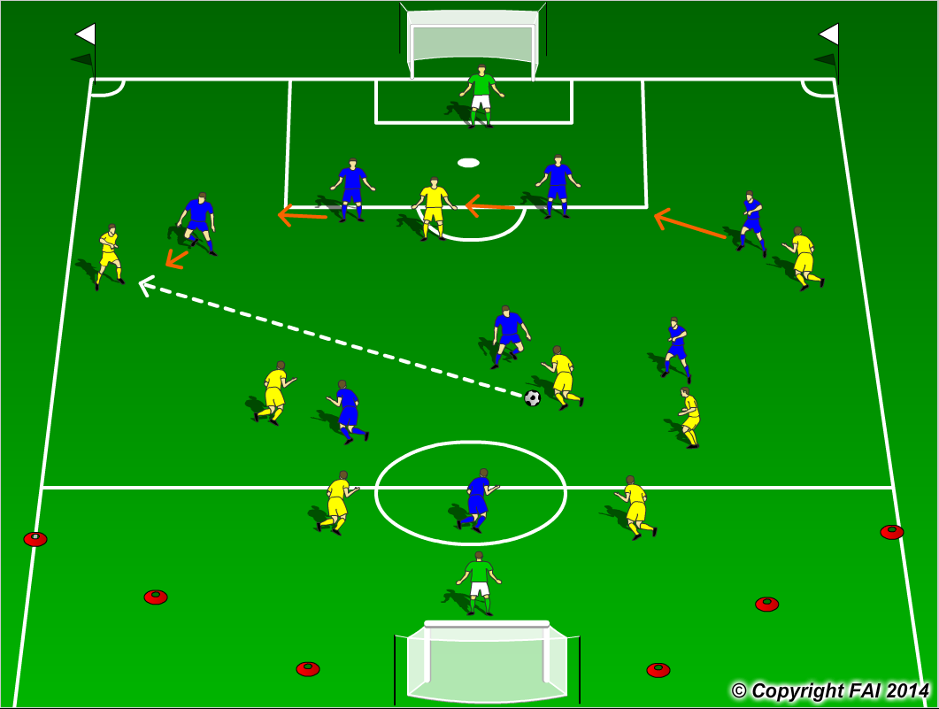

ORGANISATION
- Area: Full width of pitch, length end line to 18 yard box. Cut off the sides on one end
- 9 v 9 Game: Blue Team 1.4.3.1 v Yellow Team 1.2.3.3
- Supply of balls in each goal

KEY FACTORS
- Defensive shape – In Midfield 2 Holding players (6 & 8) and an Advanced Midfielder (10), Back 4 compact, Goalkeeper off his line
- Blue Team must move as a team as the ball is passed around the pitch, making it difficult to play through them. Keep shape don’t allow opposition to pull players out of position
- 1 v 1 Defending – Close Quickly, put on the brakes, Defending stance, Delay and Deny
- Pressure and Cover, Balance – Nearest man presses, second close cover, Opposite Full Back tucks in to give balance while keeping open body shape
- Communication from players behind is key
- Opened body shape when Defending see the ball and man
- Goalkeeper acts as Sweeper/Keeper
- When ball is won, look to play forward as quickly as possible through quality passing

NOTES
100% concentration needed, communication between players is vital

