THEME
2v2 Speed with Transition

DESCRIPTION OF PRACTICE (TECHNIQUE / SKILL)
A practice designed to improve players speed, dribbling, feints and combination play with transition to defend

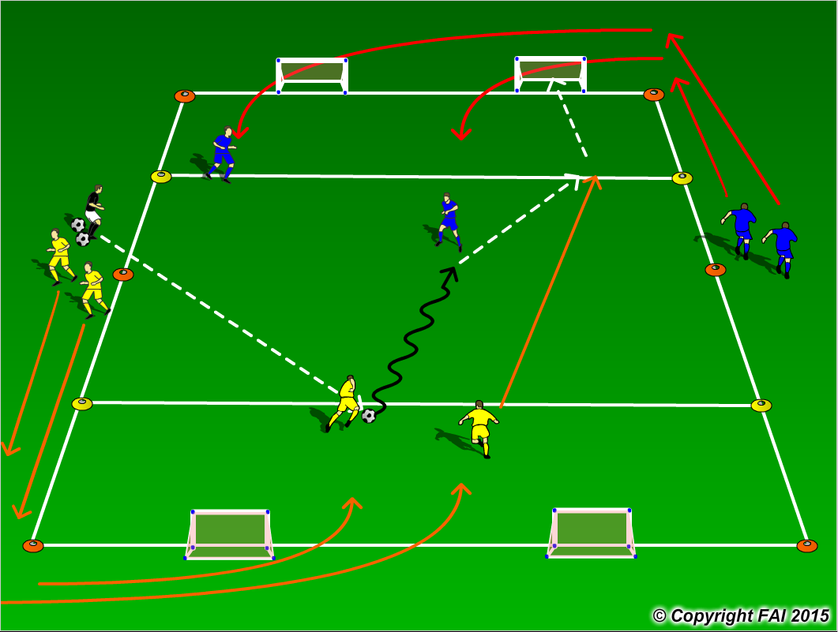

ORGANISATION
- Area: 40 x 20 metres with zones at either end marked in yellow cones, (shooting zone)
- 2 Yellows v 2 Blues – Yellows attacking, Blues defending
- On coaches signal, players sprint towards the goals
- Yellow Team: both players sprint around the first goal
- Blue Team: one player sprints around the first goal, with the second player sprinting around the second goal
- The coach passes to the Yellow team as they aim to take advantage of a quick 2v1 situation, while Blue team try to delay and recover into a 2v2 with emphasis on winning the ball
- If Blue team win possession they transition to attack the other end, while Yellow team transitions to defend
- In order for both teams to score, a player must be inside the shooting zone before attempting a shot at either goal
- Have a supply of footballs to keep the practice continually flowing

KEY FACTORS
- Let the game flow freely, not too much stops, let the players solve the problems
- Good first touch
- Encourage players to play with their head up – dribble when space is in front
- Angles and distance of support, can the player on the ball pass to you?
- Creative – can players use feints/disguises?
- End product
- Quick transition to both attack and defend – must be done at speed, think counter attacks
- Communication, movement and awareness is key – take up positions away from the defenders

NOTES
Demand intensity – practice to be performed at high speed. Give time limit for both teams to score when in possession – match realistic

