THEME
3 v 2 Attacking with 3 v 4 Transition to Defend

DESCRIPTION OF PRACTICE (TECHNIQUE / SKILL)
A functional practice designed to improve players awareness, passing, movement and finishing with transition to defend

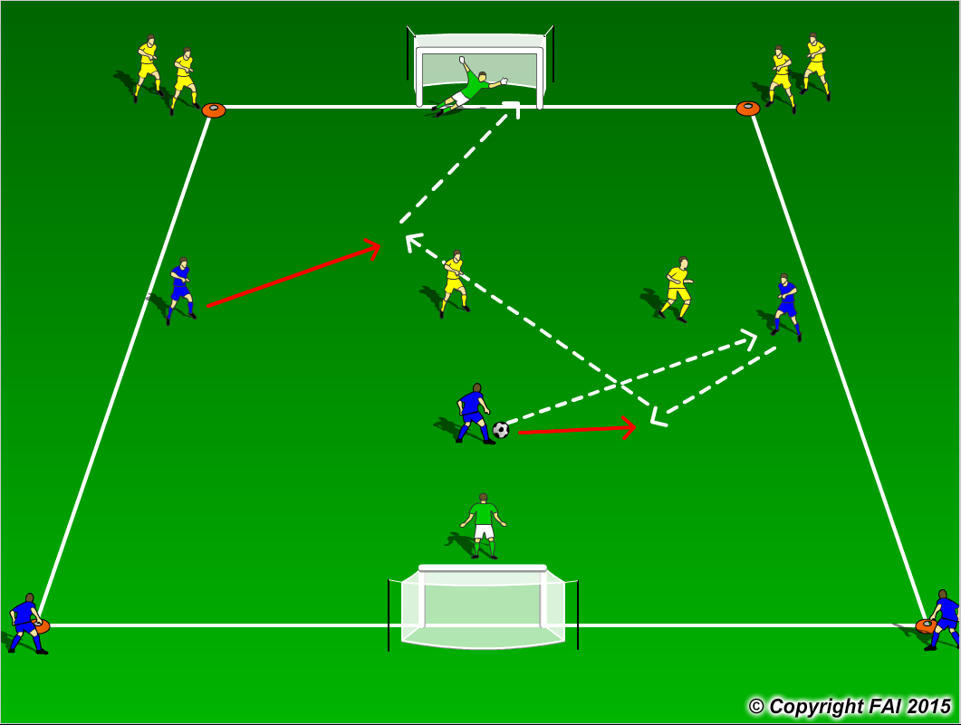
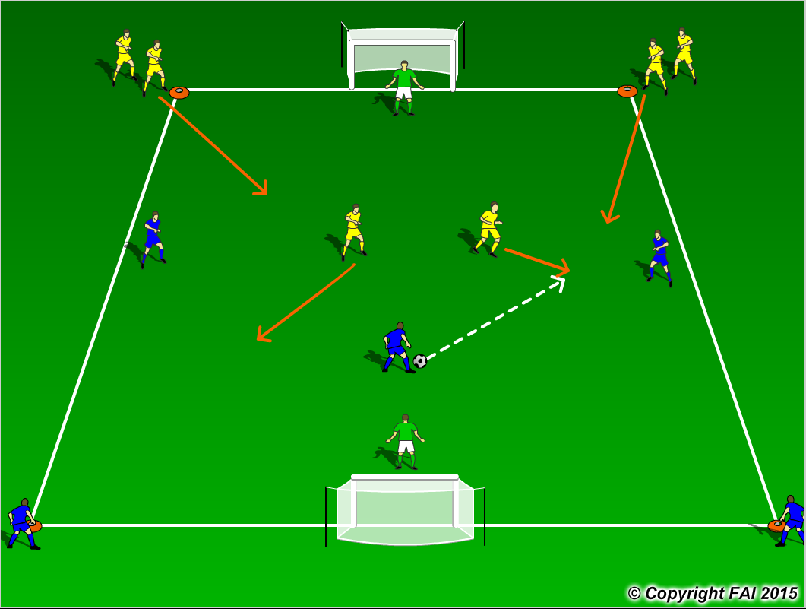

ORGANISATION
- Area: 40 x 30 metres
- 3 Blues v 2 Yellows + 2 Goalkeepers. Both Blue and Yellow players at either side as seen above.
- 3 Blues start game against 2 Yellows and try to create a goal scoring opportunity as seen above in diagram 1
- If Yellow team wins the ball they transition to attack with 2 teammates joining them in an overload as seen above in diagram 2
- Rotate players to give equal opportunity to attack and defend

KEY FACTORS
- Look for players to spread out in possession and make the pitch as big as possible
- Encourage players to play with their head up and check shoulder so they can find the free player and be aware of pressure from opposition
- Angles and distance of support, can the player on the ball pass to you?
- End product
- Quick transition to both attack and defend
- Communication and awareness is key

NOTES
Let the game flow freely, not too much stops, let the players solve the problems. The movement and communication of the players off the ball is key, take up positions away from defenders. The work rate from defending team must be quality. Look for high intensity. Give time limit for Yellow team to score on winning possession

