THEME
5v2 Positional Rondo

DESCRIPTION OF PRACTICE (TECHNIQUE / SKILL)
A Practice designed to improve players passing, decision making and positional play with transition

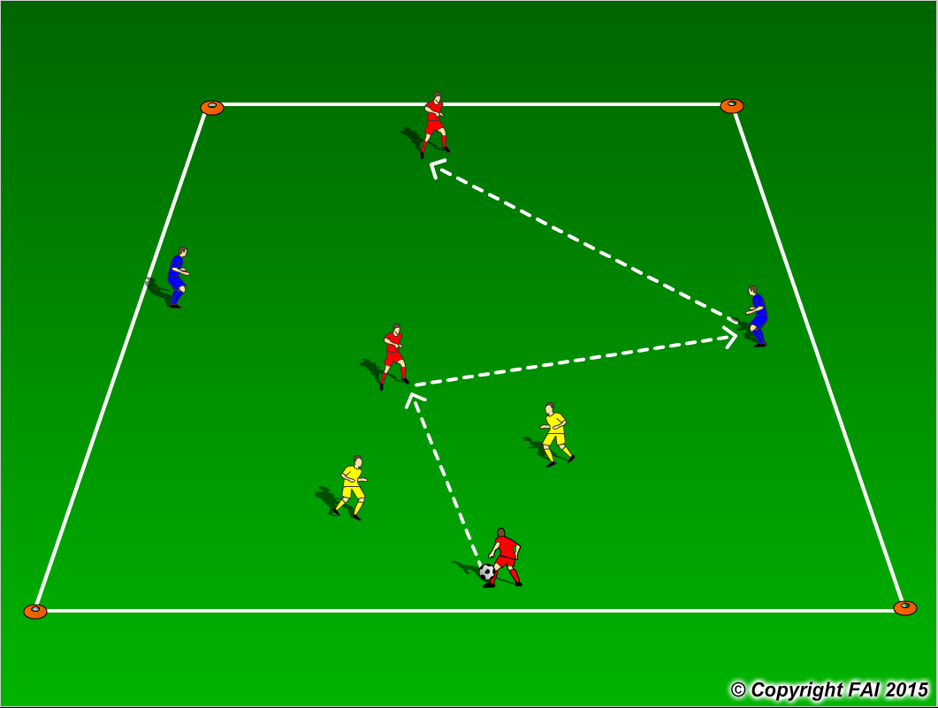

ORGANISATION
- Area: 20x25 metres
- 2 Blues + 3 Reds v 2 Yellows
- Red Players - CB, CM, CF. Blue players – RB, LB
- 3 Red players (neutral) play through the middle of the area with the 2 Blue players (attacking) positioned on either side with the 2 Yellows (defenders) in the middle area trying to win the ball.
- The Red players combine with the Blue players in an attempt to keep possession.
- If Yellow players win the ball they now take up the positions of the Blue players while the Blue players must now transition to defend
- Play for 3-4 minutes with a 30 second rest period
- Have a supply of footballs to keep the practice continually flowing

KEY FACTORS
- Quality and selection of pass
- First touch/Body shape /Back foot
- Angles and Distance of support
- Width and depth – Penetrating Pass
- Awareness of space and defender
- Patience in possession – no forced/rushed decisions
- Transition to Defend – can we win ball back as quickly as possible
- Transition to Attack – width and depth as quickly as possible

NOTES
Demand high intensity. If players of a high ability encourage one/ two touch football.

