THEME
Possession 6 v 6 with transition

DESCRIPTION OF PRACTICE (TECHNIQUE / SKILL)
Possession practice to improve players passing, movement and decision making

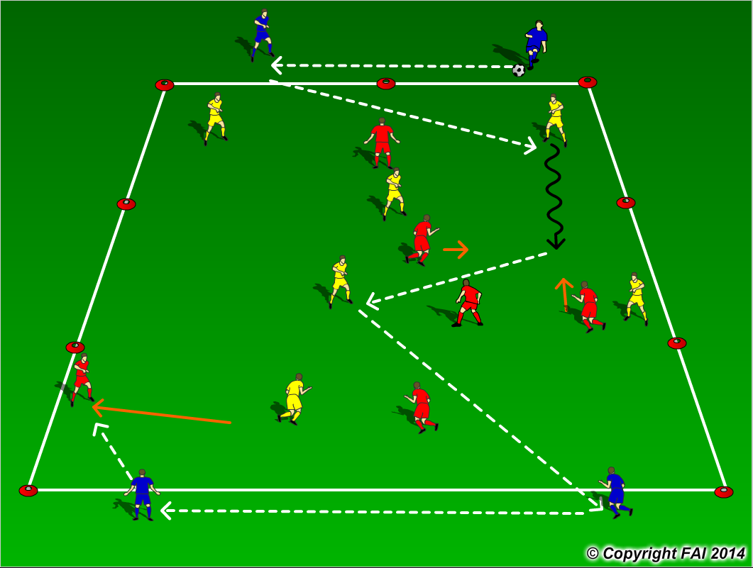

ORGANISATION
- Area: 60 metres x 30 metres
- 6v6 inside the area, formation for both teams 2 defenders, 3 midfielders (6 Holding Midfielder, 8 & 10 Attacking Midfielders) and 1 striker with 4 Blue players, 2 at each end, Blue players cannot be tackled
- Yellows players play to one end (as per diagram) Blue player that receives transfers to the second blue player that passes into Reds, Reds then looks to play to the other to Blue players (Transitions)

KEY FACTORS
- Quality of pass – pace, weight and accuracy
- Individual movement to receive pass, open body shape, looking to play forward.
- Pass to feet or space? Let players make decisions
- Passing triangles – always at least two options for player on the ball
- Get defenders to take the ball into midfield to create 4 v 3 in central area
- Get Midfielders to play in between and behind opposition
- Communication between players
- Quick Transitions important for both teams

NOTES
Keep intensity high, have supply of balls on the outside. Size of grid depends on quality of players may need to make bigger or smaller.

