THEME
5 v 3 + 2 Positional Possession with Transition

DESCRIPTION OF PRACTICE (TECHNIQUE / SKILL)
A Functional practice designed to improve players passing, decision making , movement and positional play in small spaces with transition

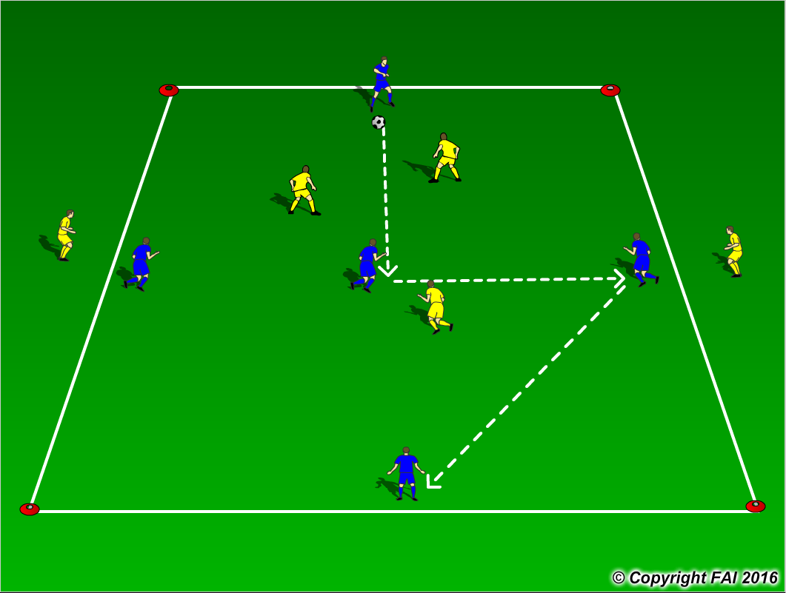

ORGANISATION
- Area: 20 x 15 metres
- 5 Blues v 3 Yellows + 2 Yellows outside area
- When in possession Blue player’s play in the shape as per diagram, if the yellow players win possession they play in this shape also, with the two Yellow’s outside the area coming inside and the two Blues on that line going outside the area
- If yellow team wins the ball can they quickly transition to attack and pass the ball to either of the two Yellows on the outside for them to join in
- Have a supply of footballs to keep the practice continually flowing

KEY FACTORS
- Quality and selection of pass – Back Foot
- Body shape/First touch/Back Foot
- Angles and Distance of support
- Width and depth – Penetrating Pass
- Awareness of space and defender
- Transition to Defend – can we win ball back as quickly as possible
- Transition to Attack – width and depth as quickly as possible

NOTES
If players of a high ability encourage one/two touch football

