THEME
3 + 2 v 3 Zonal Possession

DESCRIPTION OF PRACTICE (TECHNIQUE / SKILL)
A functional practice designed to improve players passing, decision making , movement, positioning and transition play

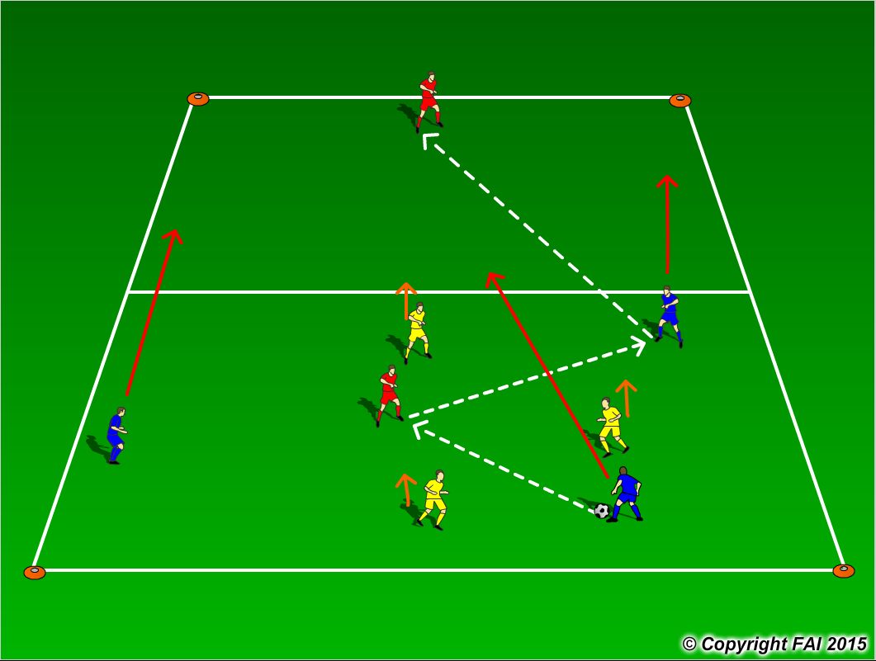

ORGANISATION
- Area: 30 x 24 metres
- 3 Blue Players + 2 Red Players v 3 Yellow Players (1 Red Player in each zone as seen above)
- When is possession Blue Team play in triangle formation, if the Yellow Team win possession they play in a triangle formation also
- Red Players always play with team in possession and can’t leave their zone
- Blue team start the practice with emphasis on keeping possession and when the opportunity arises they can transfer the ball to the Red player in the other zone. After transferring the ball the Blue team and the Yellow team must also transfer into that zone
- When not in Possession Yellows/Blues can leave their position and press to win the ball back
- Have a supply of footballs to keep the practice continually flowing

KEY FACTORS
- Quality and selection of pass
- Body shape/Receive on Back Foot /First Touch
- Angles and Distance of support
- Width and depth – Penetrating Pass
- Awareness of space and defender
- Transition to Defend – can we win ball back as quickly as possible
- Transition to Attack – width and depth as quickly as possible

NOTES
If players of a high ability encourage two touch

