THEME
Small Sided Game 4 v 4 + 4 Possession

DESCRIPTION OF PRACTICE (TECHNIQUE / SKILL)
A practice designed to improve players passing, movement and decision making

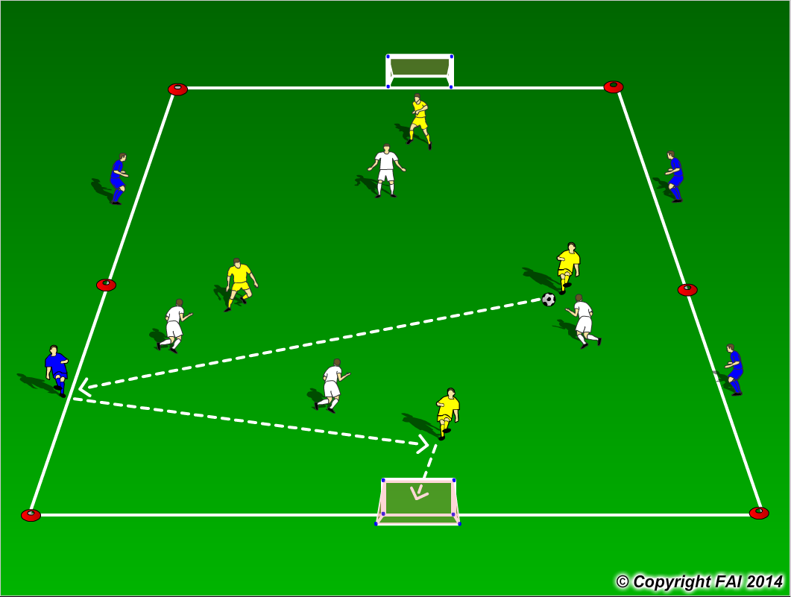

ORGANISATION
- Area 30 x 20 metres
- 4 v 4 with 4 target players on the outside
- Formation 1.2.1 both teams (Diamond Shape)
- Target players cannot be tackled, can restrict them to one/two touch
- Can add conditions such as to score players must finish on their first touch
- Team that scores stays on and team that concedes changes with target players

KEY FACTORS
- Create space (width and depth) as a team and individual
- Head up when in possession looking to play forward at every opportunity
- Create scoring opportunities though combination play (Wall passes, set up passes, third man runs)
- Create space for shooting opportunities for you or a teammate
- Quality finishing

NOTES
Balls in each goal to keep game at high tempo

