THEME
4 v 4 Possession with transition

DESCRIPTION OF PRACTICE (TECHNIQUE / SKILL)
A functional practice designed to improve players passing, movement and decision making

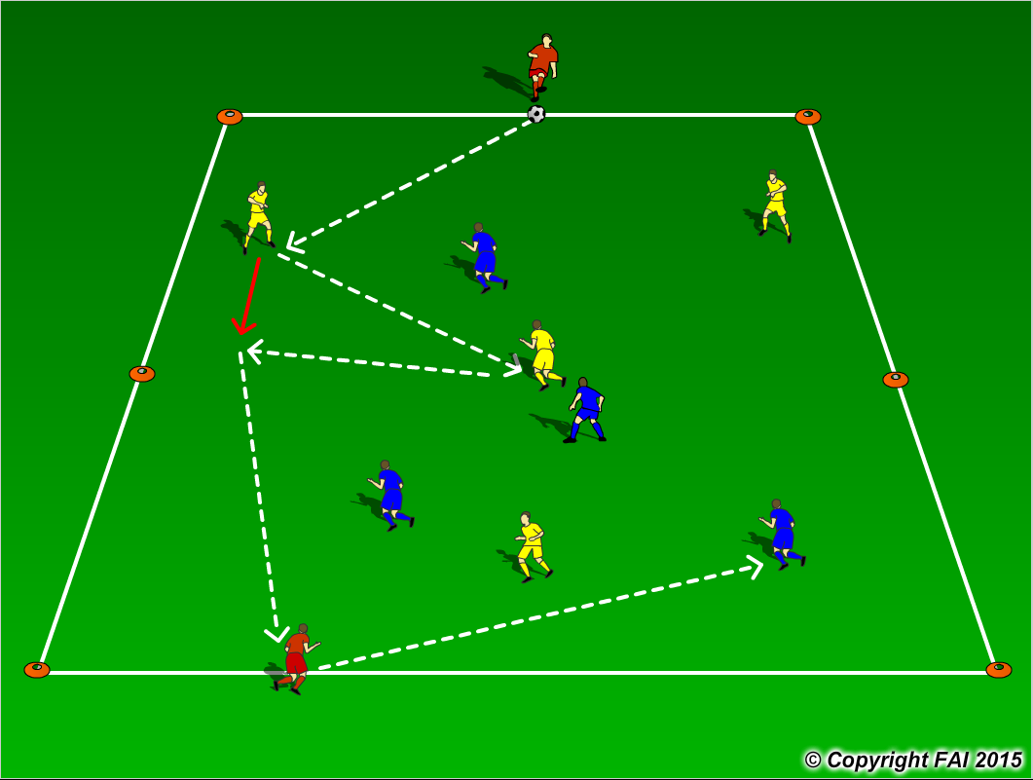

ORGANISATION
- Area: 30 metres x 20 metres
- 4 v 4 inside the area, formation for both teams (Yellow and Blue Players) 2 defenders, 1 midfielder, 1 striker with 2 Red target players, 1 at each end
- Red players cannot be tackled and can move along the end line to receive a pass
- Yellows players play to one end (as per diagram) Red player that receives, passes the ball into Blue Players, Blue players must then looks to play to the other to the opposite Red Player
- If the ball goes out of play, game restarts with a kick in from opposite team

KEY FACTORS
- Team Shape – width and depth
- Quality of pass – pace, weight and accuracy
- Individual movement to receive pass, open body shape, looking to play forward.
- Pass to feet or space?
- Passing triangles – always at least two options for player on the ball
- Communication between players
- Quick Transitions important for both teams

NOTES
Keep intensity high, have supply of balls on the outside

