THEME
1 v 1 Defending with Transition to Attack

DESCRIPTION OF PRACTICE (TECHNIQUE / SKILL)
A functional practice designed to improve players ability in 1 v 1 Defending with Transition to Attack

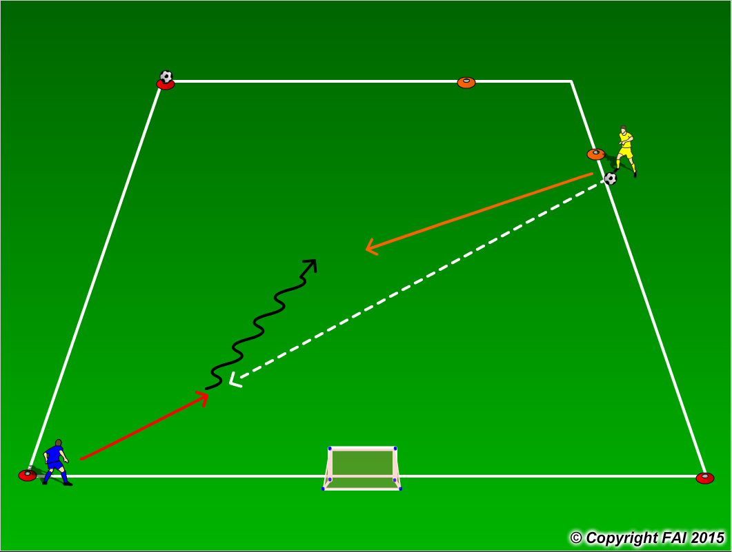

ORGANISATION
- Area 15 x 15 metres
- 1 Blue player v 1 Yellow player
- Yellow player (Defender) starts the game by passing the ball to the Blue player (Attacker)
- Attacking player attempts to dribble through the orange cones while Defender attempts to force attacker towards the ball on the cone or win the ball.
- If the Yellow player wins the ball, he/she must Transition to Attack and attempt to score in the small goal, Blue player Transitions to Defend
- To make the game competitive and demand Defending qualities, if the Attacker dribbles through the orange cones it is 2 points scored and if the Attacker is forced towards the ball on the cone it is 1 point. If Defender wins the ball and scores in the goal it is 3 points

KEY FACTORS
- Close down quickly, but under control
- As defender travels to close down attacker – assess attackers first touch
1. Poor 1st touch – win the ball
2. Good 1st touch delay
- Body shape/stance – low, side on
- Jockey, delay – be patient wait for opportunity to win the ball
- Use back foot to perform block tackle
- If ball is won transition to attack

NOTES
Make sure that players play until goal is scored or out of play, and are aware of transition

