THEME
Dribbling – 4 v 4 End Zone Game

DESCRIPTION OF PRACTICE (TECHNIQUE / SKILL)
A Practice designed to improve players 1 v 1 dribbling and changes in direction in a small sided game

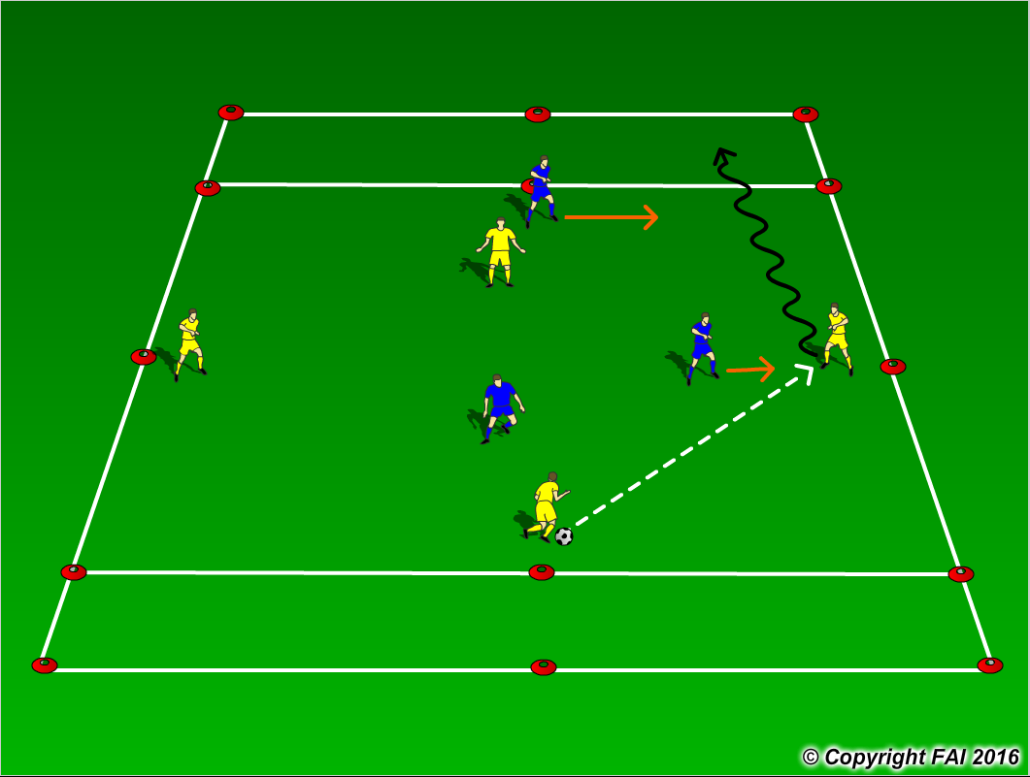

ORGANISATION
- Area 25 x 30 metres, with 3 metres end zone
- No offside
- When the ball leaves play, players are encouraged to dribble the ball back into play. If that isn’t an option they can pass.
- The attacking team score by dribbling the ball into the oppositions end zone and stopping the ball in the zone

KEY FACTORS
- Let the game flow freely
- Emphasis the diamond shape to create 1v1 situations
- Encourage creative play
- Let the players solve the problems, ask questions
- Close control, head up, use both feet
- Changes of direction, don’t sacrifice technique for speed
- Be patient

NOTES
Rotate players in different positions, let the players play without fear of failure.

