THEME
1 v 1 Defending with Transition

DESCRIPTION OF PRACTICE (TECHNIQUE / SKILL)
A functional practice designed to improve players 1 v 1 Defending

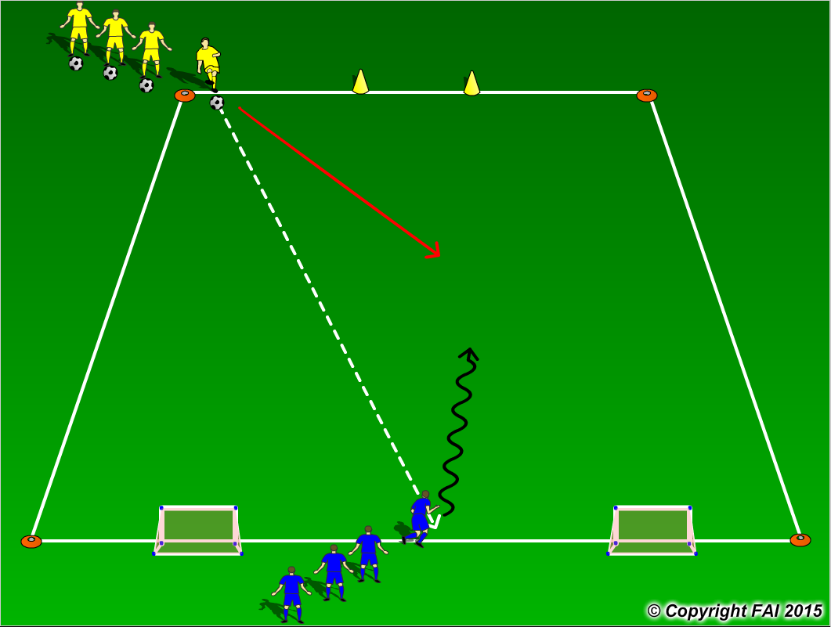

ORGANISATION
- Area 15 x 12 metres
- Yellow players (Defenders) pass the ball to the Blue players (Attackers) and Defends
- Blue players score by dribbling through the Yellow gate, if the Yellow players win the ball they can score by passing the ball into either of the two small goals at the opposite end

KEY FACTORS
- Close down quickly, but under control
- As Defender travels to close down attacker – assess Attackers first touch
1. Poor 1st touch – win the ball
2. Good 1st touch delay
- Body shape/stance – low, side on
- Jockey, delay – be patient wait for opportunity to win the ball
- Show Attacker on to his other foot or use the sideline as another Defender
- Use back foot to perform block tackle
- If ball is won transition to attack

NOTES
Make sure that players play till goal is scored or ball goes out of play and are aware of the transitions

