THEME
1 v 1 Shielding and Turning with Transition to Defend

DESCRIPTION OF PRACTICE (TECHNIQUE / SKILL)
A functional practice designed to improve players 1 v 1 ability in movement, shielding, turning and dribbling with transition to defend

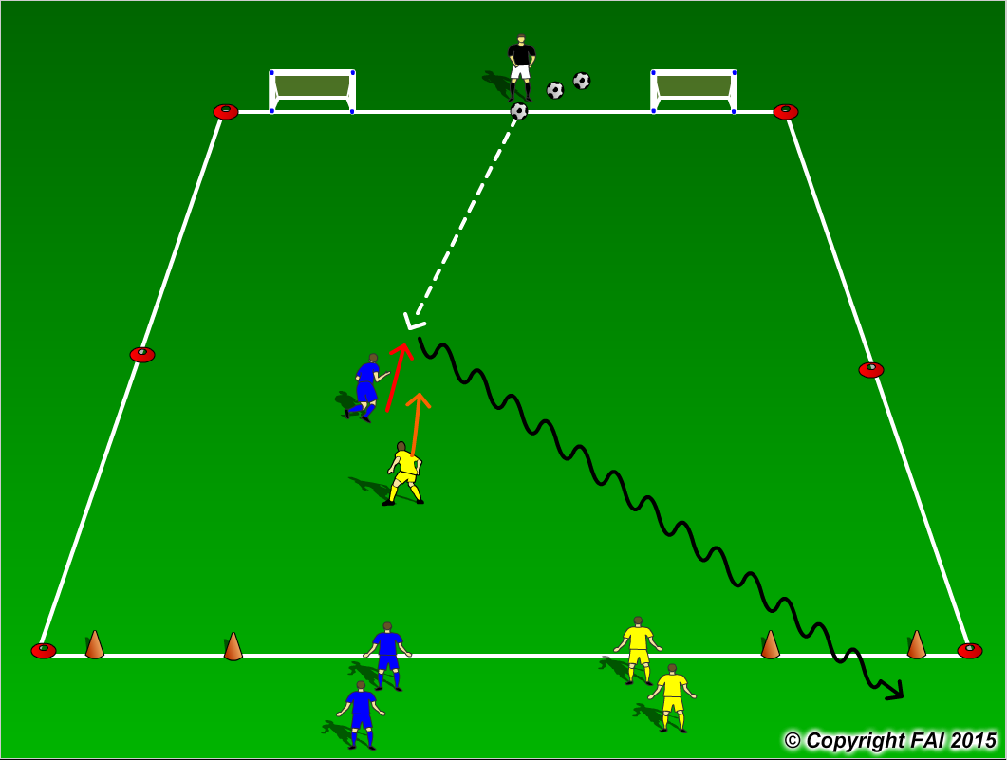

ORGANISATION
- Area 20 x 15 metres
- 1 Blue v 1 Yellow with Coach acting as server
- Both players start inside the area with the Blue player looking to create movement to receive the ball from the Coach
- On receiving the ball, the Blue player must shield the ball from the Yellow player before attempting to turn and dribbling through either of two small goals as seen in the diagram above
- If the Yellow player wins the ball, he/she must pass through either of two small goals at the opposite end

KEY FACTORS
- Quick awareness and movement
- When shielding can player take the ball on foot furthest away from defender while having a side on position, can the player keep the defender at arm’s length
- Can player change direction (turning) with the ball under pressure
- If defender is very tight can Attacker turn off their first touch
- Quick acceleration while dribbling after turning defender
- If ball is lost quick transition to defend

NOTES
Make sure that players play till goal is scored, i.e. dribble through either goal, or ball goes out of play and are aware of the transitions. If players of good quality give them time limit to score

