THEME
4+7v4 Possession with Transition

DESCRIPTION OF PRACTICE (TECHNIQUE / SKILL)
A Practice designed to improve players passing, decision making , movement and positional play with transition

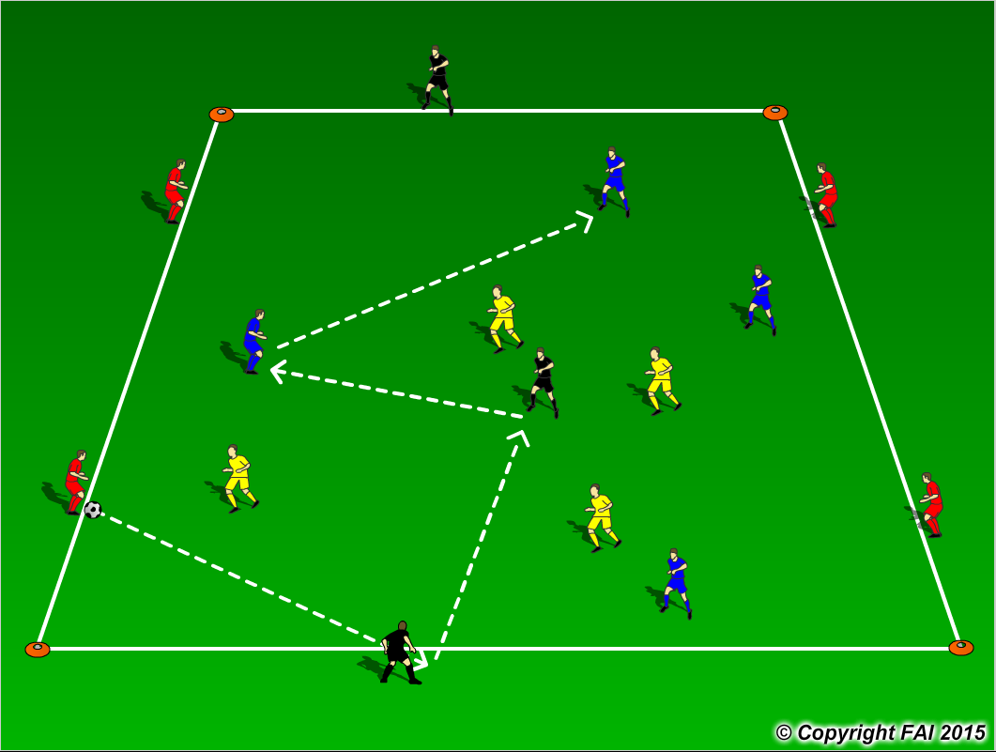

ORGANISATION
- Area: 30 x25 metres
- 4 Blues + 4 Reds & 3 Blacks v 4 Yellows
- Red players provide the width, with 2 Black players providing depth with 1 central player
- Blue team start the practice and can use both the Red and Black players in possession
- Yellow team attempt to win the ball and if successful quickly transition to attack now using both the Red and Black players with the Blue team now transitioning to defend
- Have a supply of footballs to keep the practice continually flowing
- Play for 3 minutes with 30 second rest period, swap teams of 4 after every rest period

KEY FACTORS
- Quality and selection of pass – Back Foot
- First touch/Body shape
- Angles and Distance of support
- Width and depth – Penetrating Pass
- Awareness of space and defender
- Decision making – speed of thought
- Transition to Defend – can we win ball back as quickly as possible
- Transition to Attack – width and depth as quickly as possible

NOTES
Demand high quality and intensity. If players of a high ability play one/ two touch football.

