THEME
Speed development with the ball 1v1

DESCRIPTION OF PRACTICE (TECHNIQUE / SKILL)
A practice designed to improve players speed in a game related practice

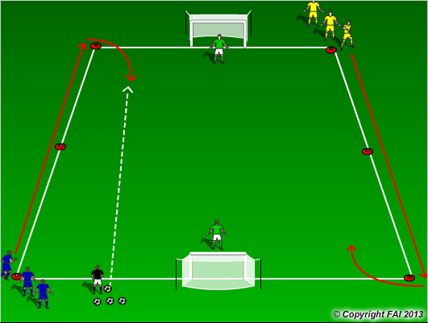

ORGANISATION
- Area: 25x20 metres
- Divide players into two groups, Gk’s in each goal
- On Coaches signal players sprint, coach gives the ball to the first player into the area
- Players play 1v1 until one scores or the ball goes out of play
- On coaches call GK’s sprint to opposite goal

KEY FACTORS
- Straight line run – technique of running – head straight, arms close to body, shoulders relaxed, balls of foot touches the ground
- Acceleration and Deceleration – both equally important
- Change of direction – turn quickly in small space, quick feet
- Ratio work to rest 1:5
- 100% effort with and without the ball

NOTES
Watch each players running technique, look to correct mistakes. Two coaches one plays in ball, second addresses any running technique issues

