THEME
1 v 1 Passing Combination and Overlap

DESCRIPTION OF PRACTICE (TECHNIQUE / SKILL)
A functional practice designed to improve players quick passing, movement, and 1 v 1 ability in dribbling and finishing under pressure with transition to defend

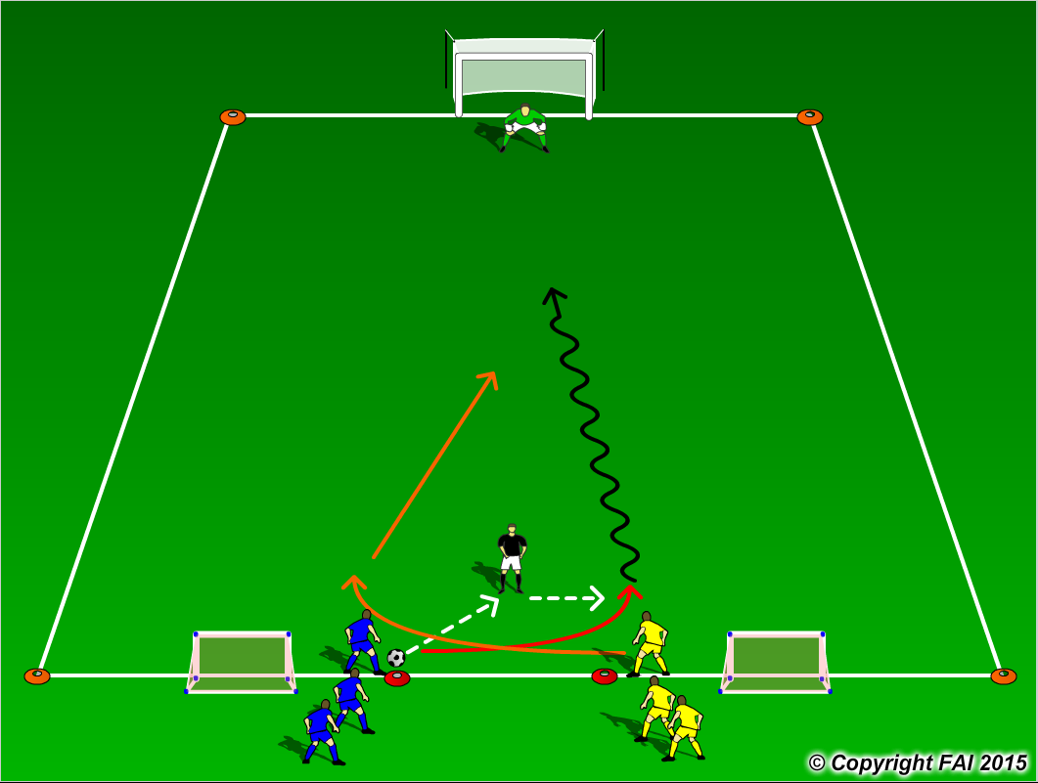

ORGANISATION
- Area 20 x 15 metres
- 1 Blue v 1 Yellow with Coach acting as server
- Blue player and coach play a wall pass with the Yellow player overlapping the Blue player on the coaches pass
- On receiving the ball can the Blue player control and dribble at speed with the opportunity to finish while being under pressure from the Yellow player
- If the Yellow player or Goalkeeper wins the ball, he/she must pass through either of two small goals at the opposite end
- Make sure players work of both sides

KEY FACTORS
- Quality of pass – pace and accuracy
- Good first touch
- Quick acceleration while dribbling
- Finishing under pressure – assess distance of defender and goalkeepers position
- Quick transition in both attack and defense

NOTES
Make sure that players play till goal is scored, i.e. a goal is scored at either end, or ball goes out of play and are aware of the transitions. If players of good quality give them time limit to score

