THEME
Attacking with Transition to Defend – Goalkeeper, Defenders and Midfielders

DESCRIPTION OF PRACTICE (TECHNIQUE / SKILL)
9 v 9 Small Sided Game designed to improve players Technique and Tactical Awareness when playing out from the back

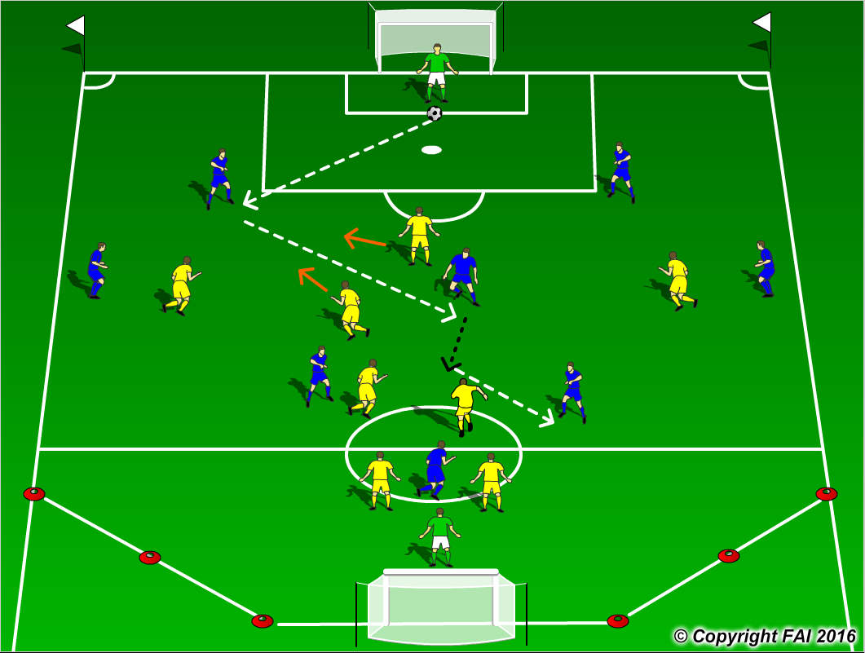

ORGANISATION
- Area: Full width of pitch, length end line to 18 yard box. Cut off the sides on one end
- 9 v 9 Game: Blue Team 1.4.3.1 v Yellow Team 1.2.3.3
- Supply of balls in each goal
- Goalkeeper starts the play at all times with the ball in the middle of 6 yard box

KEY FACTORS
- Starting positions of Center Backs – edge of 18 yard box, Full Backs pushed high up near touchline
- Midfield with Holding Midfielder (6) and 2 Advanced Midfielders (8 & 10)
- Quality and selection of pass
- First touch and body shape (opened looking to play forward)
- Angles and distance of support
- Awareness and communication
- Transition to defend if ball is lost, can they win it back as quickly as possible (Pressing as a unit)

NOTES
Get the Yellow Team to drop off and put on limited pressure at the start to get the Blue team comfortable in possession. Goalkeeper’s role very important, Quality of passing and decision making crucial

