THEME
Small sided game – Man to Man Marking - Conditioning Exercise

DESCRIPTION OF PRACTICE (TECHNIQUE / SKILL)
A Practice designed to improve players aerobic resistance within a SSG with a focus on man to man marking

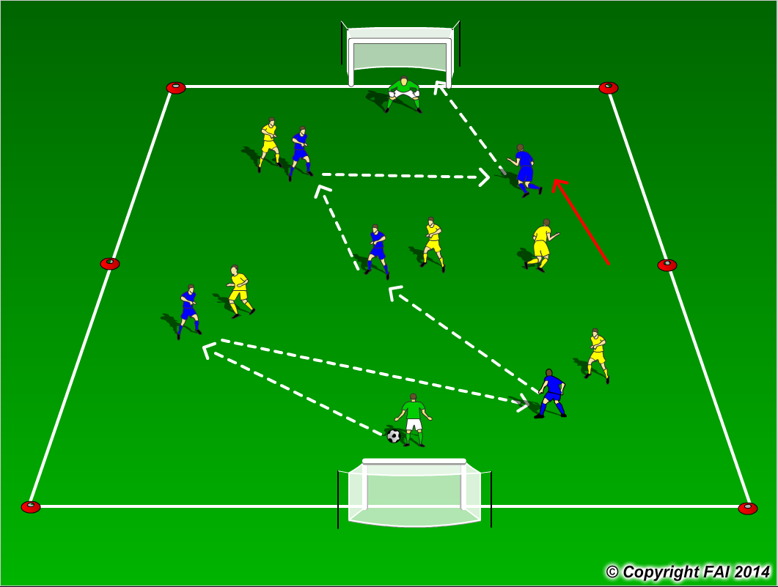

ORGANISATION
- Area : 40 x 24 metres
- Two teams, 5 Blues v 5 Yellows + 2 GK’s
- The outfield must each pick an opposition player to man mark – results in physical competition and aerobic resistance work
- The coach can call a change during the game so the players move to man mark another opposition
- 6 minute games

KEY FACTORS
- Let the game flow freely, not too much stops, let the players solve the problems
- When being man marked, the player with the ball needs –
Use of good body shape
Strength to protect the ball
- When players look to receive the ball, they should –
Quick and clever movement to escape opposition
Receive and shoot quickly as they will be under tight pressure
- Encourage players when in possession to play high tempo football to lose opposition
- Transition to Defend – can we regain the football quickly and man mark quickly to put opposition under pressure?
- Transition to Attack - can we create goal scoring opportunity as quick as possible?
- Communication
- End product

NOTES
Demand intensity from players. Offside in play

