THEME
Speed development – Standing start speed and reactions

DESCRIPTION OF PRACTICE (TECHNIQUE / SKILL)
A practice designed to improve players speed from standing position

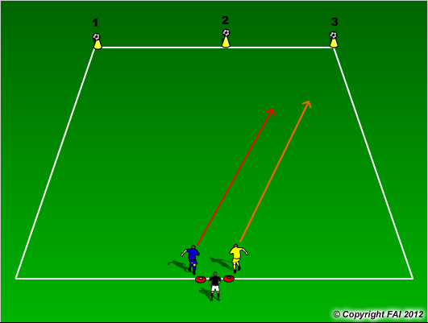

ORGANISATION
- Area: 20 metres x 30 metres
- 1 v 1, Blue v Yellow, max 5 per line
- Three footballs placed on top of 3 cones at the end of the area
- On coaches signal players must knock one of balls of the cone, first to knock football wins
- Coach call number but could change before players get to football (reaction)
- Coach can introduce football that he places between players and they must use this to knock football of cone

KEY FACTORS
- Straight line run – technique of running – head straight, arms close to body, shoulders relaxed, balls of foot touches the ground
- Standing start – watch that players have forward lean and don’t put their foot backwards first
- Acceleration and Deceleration – both equally important
- Change of direction – turn quickly in small space, quick feet
- 100% effort
- 1.5 work rest ratio

NOTES
Get the middle player to just to hold a bib so there is a quick turn over. Only play for 5-8 minutes max, Quality rather than Quantity.

