THEME
3 v 1 + 2 Attacking Overload

DESCRIPTION OF PRACTICE (TECHNIQUE / SKILL)
A functional practice designed to improve players awareness, passing, movement and finishing

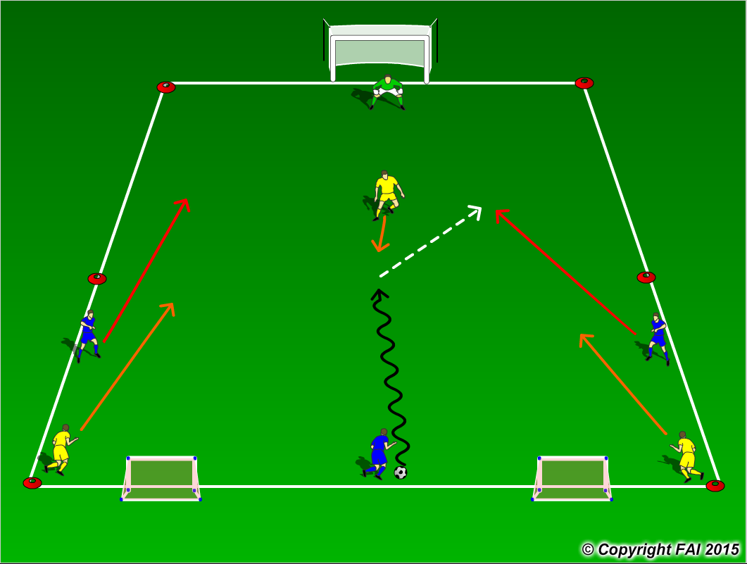

ORGANISATION
- Area: 30 x 20 metres
- 3 Blues v 3 Yellows + 1 Goalkeeper
- 3 Blues start game with an 3 metre advantage on 2 Yellows to attack 1 Yellow on goal
- If Yellow team win the ball they must score in either of the small goals
- When the ball leaves the pitch game restarts with Blue team

KEY FACTORS
- Look for players to spread out in possession and make the pitch as big as possible
- Encourage players to play with their head up and check shoulder so they can find the free player and be aware of pressure from opposition
- Angles and distance of support, can the player on the ball pass to you?
- End product
- Team Defending – can the lone defender delay the attacking opposition until teammates catch up with play
- Communication and awareness is key

NOTES
Let the game flow freely, not too much stops, let the players solve the problems. The movement and communication of the players off the ball is key, take up positions away from defenders.
The work rate from defending team must be quality. Look for high intensity

