THEME
1 v 1 Dribbling into Crossing and Finishing

DESCRIPTION OF PRACTICE (TECHNIQUE / SKILL)
A functional practice designed to improve 1 v 1 Dribbling, Crossing and Finishing with Transition

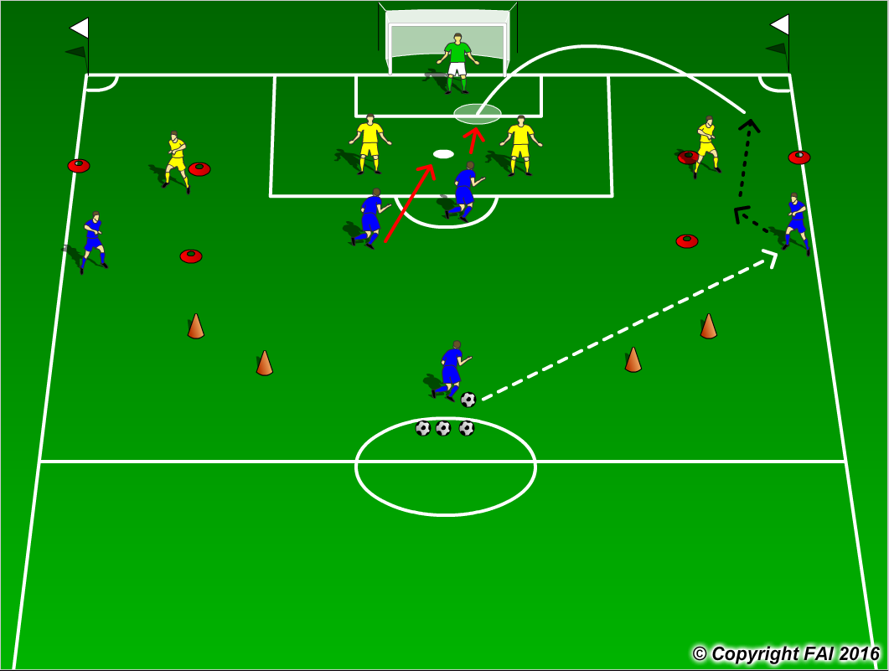

ORGANISATION
- Area half full size pitch, 2 10 x 10 metres area’s for 1 v 1 Dribbling
- Midfield Blue player plays a ball into Blue Winger who Attacks Yellow Full Back and must get over one of the two lines marked with cones that the Yellow Full Back is protecting, the Winger then looks to cross into area or combine where there is Blue Center Forward and Advanced Midfielder against 2 Yellow Center Backs and Goalkeeper
- If the Yellow Teams win the ball they can score by passing through the two gates marked with Red cones

KEY FACTORS
1 v 1 Dribbling
- Positive first touch, get the ball out of your feet, Attack the Defender with the ball under control
- Keep your head up to assess Defenders position, Make your move (Skill, trick or speed)
- Decision – Beat Defender on the inside and combine with Attackers or outside and cross
Finishing
- Movement for crosses be unpredictable, don’t be in the same line, play off Defenders blindside

NOTES
Make sure Blue players react quickly on losing possession and Transition to Defend

