THEME
Attacking 3 v 2 with Transition to defend

DESCRIPTION OF PRACTICE (TECHNIQUE / SKILL)
A functional practice designed to improve players passing, movement, finishing and transition to defend

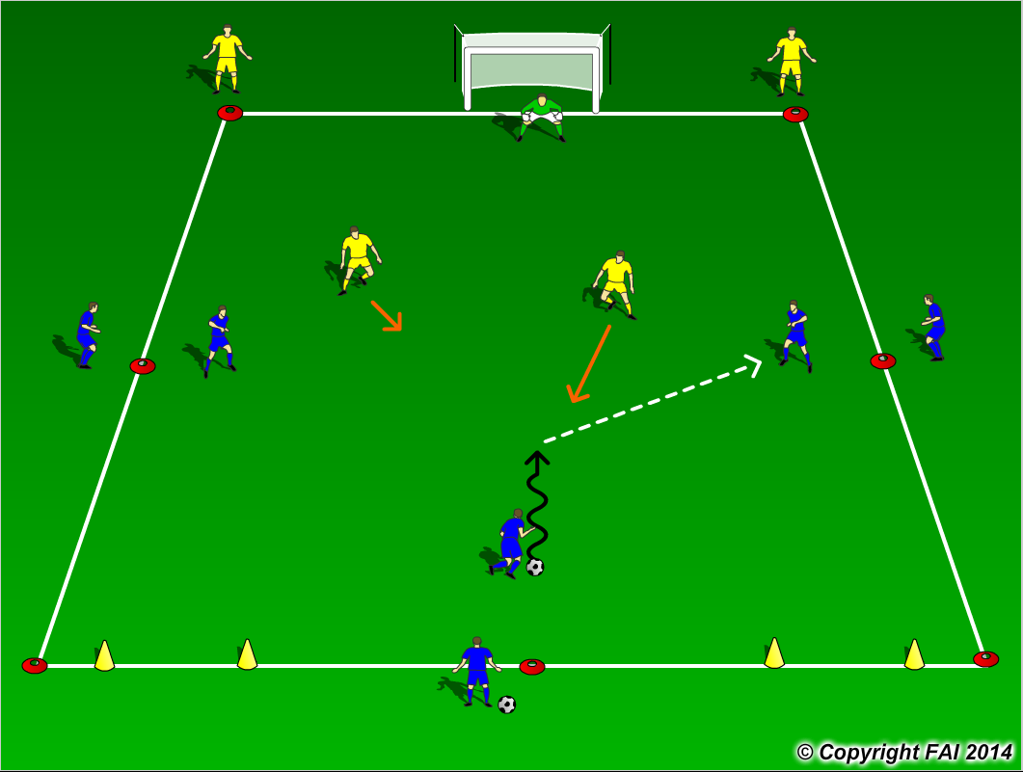

ORGANISATION
- Area: 25 x 20 metres
- 3 Blues v 2 Yellows + 1 Goalkeeper
- Blue team start with possession and try to score
- The Yellow players must try and win the ball and if successfully can score into either of the small goals
- If the Blue team lose possession of the ball they must try and regain possession
- If Goalkeeper saves a shot from Blue team, the game continues with Goalkeeper and Yellow players trying to score in either of the small goals

KEY FACTORS
- Quality and selection of pass
- Body shape/Back Foot/First Touch
- Angles and Distance of support
- Awareness of space and defender – Attack Defender to free player’s
- Finishing, assess position of Defender and Goalkeeper
- Transition to Defend – can we win ball back as quickly as possible?
- Transition to Attack – can Yellow play quick pass into either of the small goals?

NOTES
Offside is in Play. Introduce time limit to score if players of a high quality

