THEME
Possession 3 v 1 with transition

DESCRIPTION OF PRACTICE (TECHNIQUE / SKILL)
A Practice designed to improve players passing, movement, decision making and transition to defending

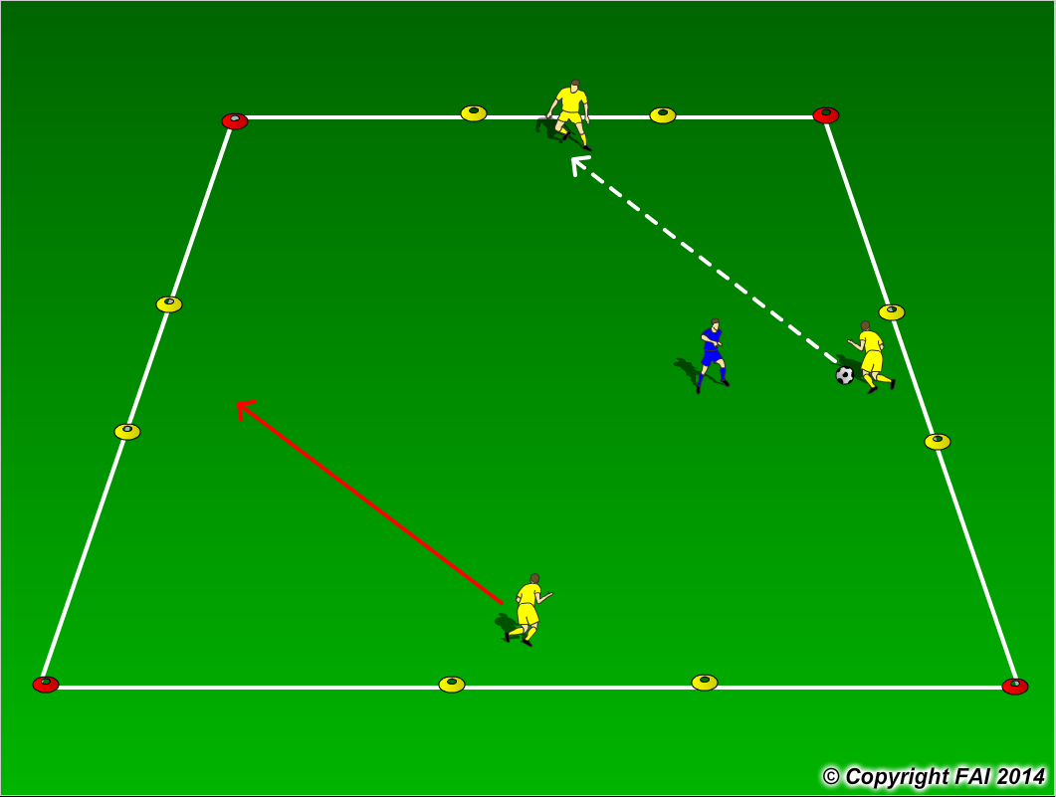

ORGANISATION
- Area: 12 x 12 metres
- 3 Yellows v 1 Blue
- Yellows start with possession and try and keep ball from the Blue player
- If the Blue player wins the ball, they can score by passing the ball through any of the 4 gates marked with Yellow cones, Yellow players must transition to defend and try and win the ball back

KEY FACTORS
- Quality and selection of pass
- Body shape/First Touch/Back Foot
- Disguise/Change of Direction
- Angles and Distance of support
- Awareness of space and defender
- Communication between players
- Transition to Defend – can we win ball back as quickly as possible

NOTES
Have supply of balls outside area, to keep the tempo high.

