THEME
2 v 2 Defending with Transition

DESCRIPTION OF PRACTICE (TECHNIQUE / SKILL)
A functional practice designed to improve players 2 v 2 Defending – Pressure and Cover

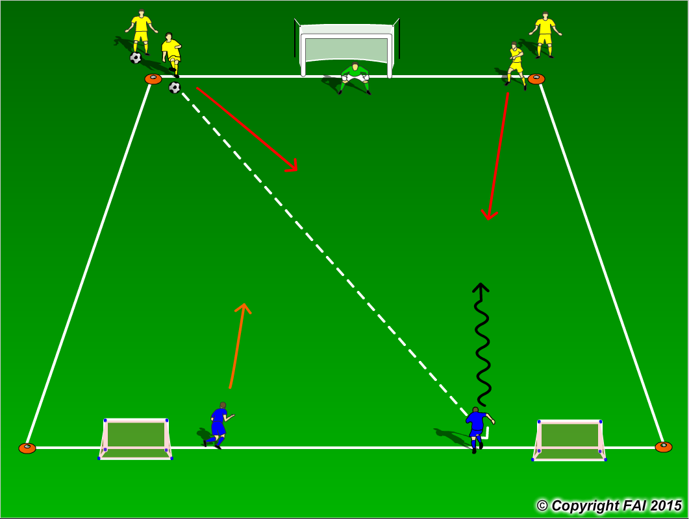

ORGANISATION
- Area 20 x 15 metres
- 2 Yellow Players v 2 Blue Players + 1 Goalkeeper
- Yellow Players (Defenders) pass the ball to the Blue Players (Attackers) and defend
- Blue Team have to score by attempting to score in the goal with the Goalkeeper, if the Yellow Players or Goalkeeper win’s/saves the ball they can score in either of the two small goals at the opposite end

KEY FACTORS
- Defenders react fast – get up quickly but under control in relation to goal
- Nearest Defender must press – as close as possible – stop forward play – 1 v 1 Defending stance
- Second Defender Covers – angles and distance – see your attacker and the ball
- Changing roles as ball is passed – in/out
- Decision making and communication are vital – Goalkeeper to be vocal
- If ball is won Transition to Attack

NOTES
Make sure that players play till goal is scored or ball goes out of play and are aware of the Transitions

