THEME
Bumper Possession 4v4+4

DESCRIPTION OF PRACTICE (TECHNIQUE / SKILL)
Possession practice to improve players passing, movement, decision making with emphasis on switching the point of attack, and transition to defend

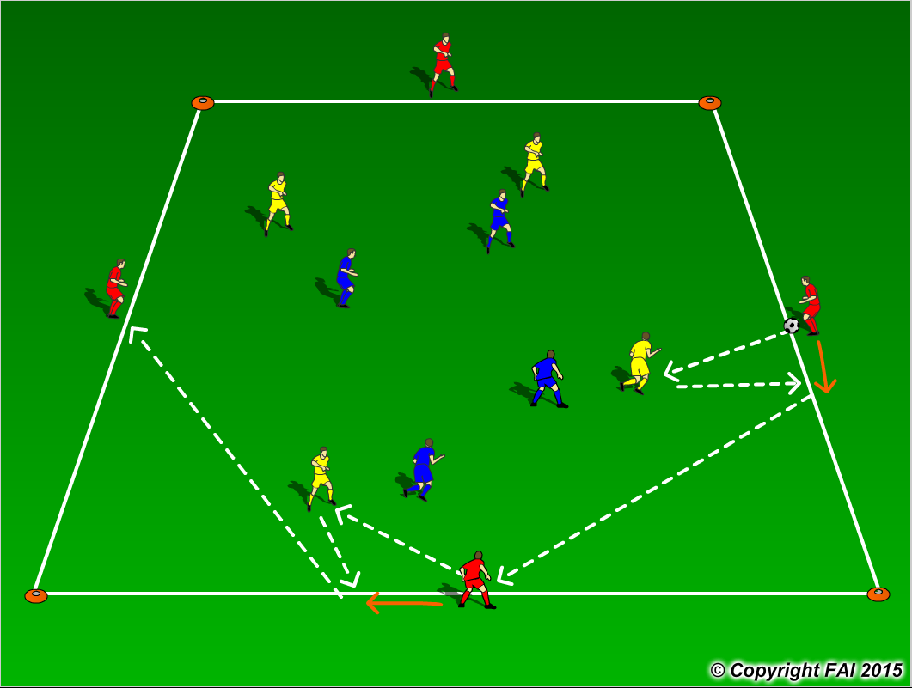

ORGANISATION
- Area: 30 x 25 metres grid
- 4v4 inside the area, wall players on the outside. When In possession 8 v 4. Wall players can only move up and down along their line and cannot be tackled
- On receiving the ball the target player must ‘bounce’ the ball off a player in the middle, and switch the point of attack to another yellow, who would attempt to do the same as seen in the diagram above
- Can progress onto when a pass is played to wall player, they come into the area and are replaced by an inside player

KEY FACTORS
- Quality of pass – pace, weight and accuracy
- Individual movement to receive pass, open body shape, looking to play forward.
- Pass to feet or space? Let players make decisions
- Passing triangles – always at least two options for player on the ball
- Play in between and behind players
- Communication between players
- Can team in possession play short combination passes to draw in the opposition before playing a long pass to open up the play?

NOTES
Keep intensity high, have supply of balls on the outside. Size of grid depends on quality of players may need to make bigger or smaller. Can use 3v3, 5v5 inside area also.

