THEME
Small sided game – 4 v 4 with small goals

DESCRIPTION OF PRACTICE (TECHNIQUE / SKILL)
A Practice designed to improve players technique, movement and decision making in a small sided game

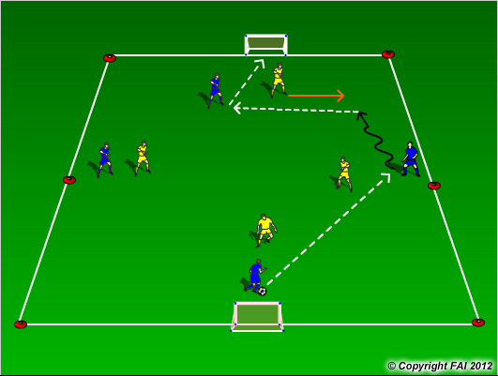

ORGANISATION
- Area : 30 x 20 metres
- Two teams, 4 Blues v 4 Yellows no Goalkeepers
- When the ball goes on of play restart with pass or dribble into play

KEY FACTORS
- Let the game flow freely, not too much stops, let the players solve the problems
- Look for diamond shape when attacking (width and depth)
- Remind players they need to keep a balance in defending and attacking
- Encourage players to react quickly to the ball going out of play, can we score? Do I need to defend?
- Look for them to take advantage of scenarios when the opposition reacts slowly
- End product

NOTES
Coach must have good supply of footballs to keep game going quickly, if you have an extra player they can play as floater

