THEME
1 v 2 Recovery Defending

DESCRIPTION OF PRACTICE (TECHNIQUE / SKILL)
A functional practice designed to improve players ability both in 1 v 1 and 1 v 2 Defending and recovery with Transition

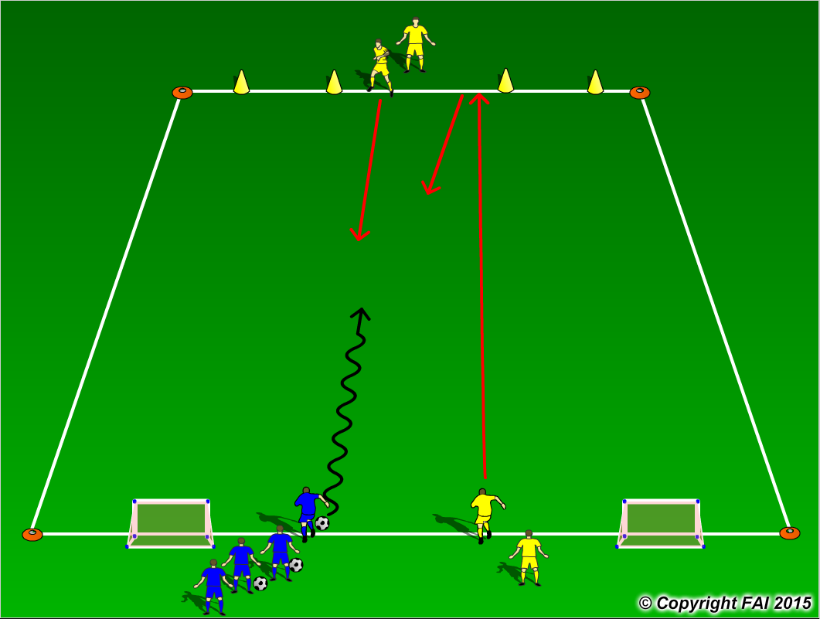

ORGANISATION
- Area 18 x 12 metres
- 1 Blue player (Attacker) v 2 Yellow players (Defenders)
- Game starts as follows:
1 – Players set up as seen above in diagram
2 – Blue player starts practice by dribbling into area with a 1 v 1 situation with Yellow player with emphasis on dribbling through either of the gates marked with cones – Yellow player looking to delay Attacker
3 – Second Yellow player that starts beside Blue Player must sprint up to the opposite end and then come into play to make it a 2 v 1 Defending situation - recovery
- If Yellow Players win the ball, they attempt to score in either of the two small goals at opposite end with Blue player now Transitioning to Defend

KEY FACTORS
- Close down quickly, but under control
- As first Defender travels to close down Attacker – assess Attackers first touch
1. Poor 1st touch – win the ball 2. Good 1st touch delay
- Body shape/stance – low, side on
- Jockey, delay – be patient wait for opportunity to win the ball
- Second Defender to recovery quickly – speed, then Defenders to press and cover
- Quick Transition in Attack on winning possession

NOTES
Make sure that players play till goal is scored, i.e. goal is scored or ball goes out of play and are aware of the Transitions. If players of high quality give them time limit to score

