THEME
11 v 11 Game

DESCRIPTION OF PRACTICE (TECHNIQUE / SKILL)
11 v 11 game designed to improve players all round Technique and Tactical Awareness

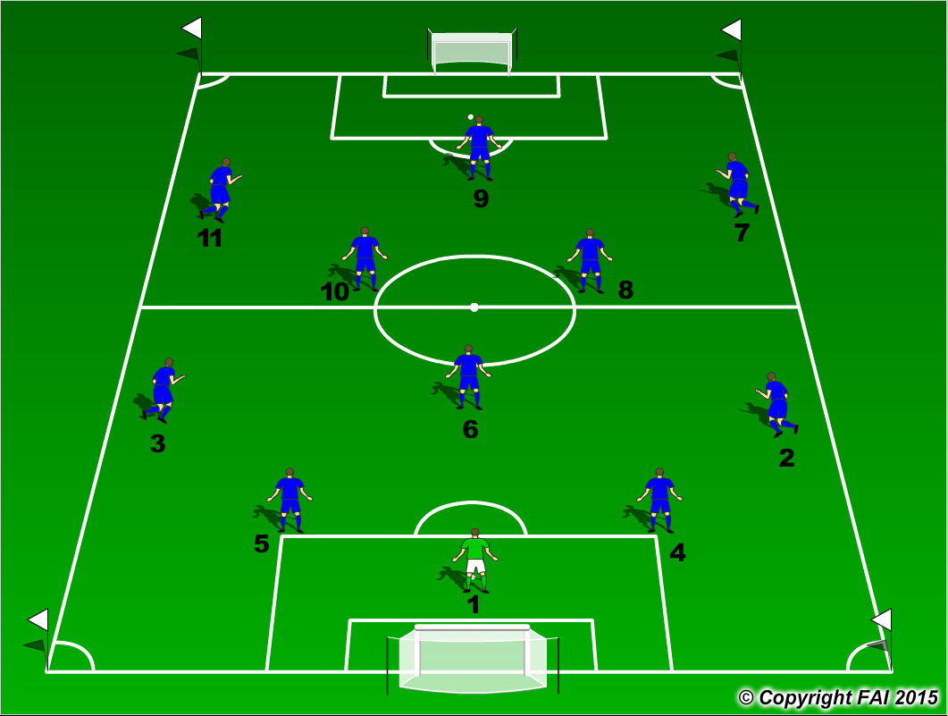

ORGANISATION
- Formation 1.4.3.3

KEY FACTORS
In Possession
- Starting positions of Defenders – wide and high, open body shape, awareness and receive on back foot
- Midfield with Holding Midfielder (6) and 2 Advanced midfielders (8 & 10)
- Quality and selection of pass
- First touch and body shape (opened looking to play forward)
- Angles and distance of support
- Awareness and communication
- Transition to Defend if ball is lost, can they win it back as quickly as possible (Pressing as a unit)
Out of Possession
- Starting Positions – narrow and compact, make it difficult for attacking team to play through passes
- Midfield with 2 Holding Midfielder and 1 Advanced Midfielder
- Make play predictable, curved runs and getting them to play into traps
- The rest of the team move in relation to pressing players – Pressure/Cover/Balance
- Communication from players behind is key
- Opened body shape when Defending see ball and man
- When ball is won, look to play forward as quickly as possible through quality passing

