THEME
6 v 2 Positional Play with Transition

DESCRIPTION OF PRACTICE (TECHNIQUE / SKILL)
A functional practice designed to improve players passing, positioning and decision making with transition

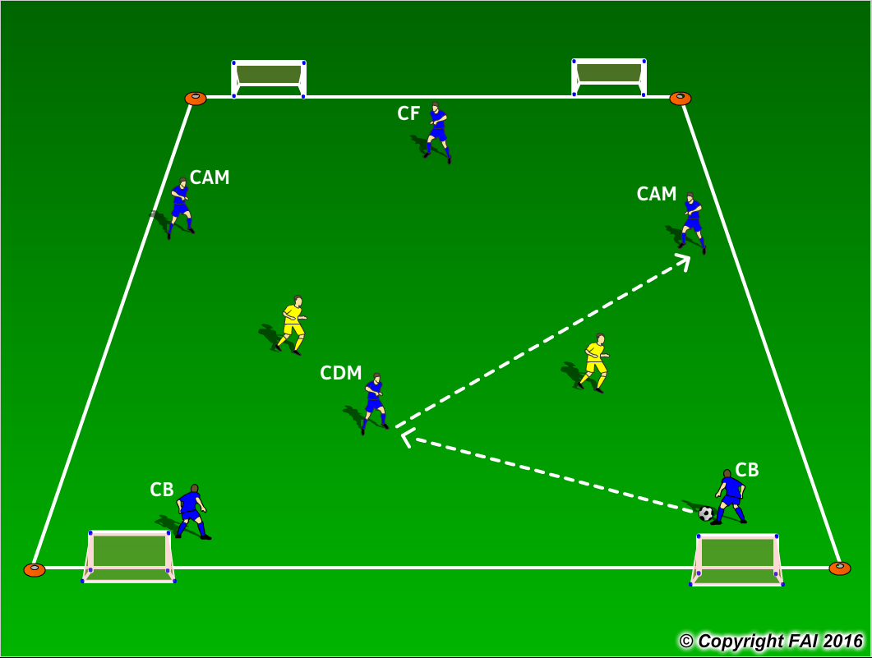

ORGANISATION
- Area: 16 x 12 metres
- Two teams: 6 Blues v 2 Yellows
- Blue Team start the practice with emphasis on maintaining positions and possession of the ball, looking to play forward from CB’s to CF with the CDM dropping in between the Centre Backs to receive and pass forward – Blue CB’s always start with the ball
- Utilize playing positions - movement from training to game
- If the Yellow team win the ball they must quickly transition to attack with emphasis on scoring in any of the four small goals. The Blue team must transition to defend quickly and try and win the ball back
- Have a supply of footballs to keep the practice continually flowing

KEY FACTORS
- Quality and selection of pass
- Body shape/First Touch/Back Foot – very important for Blue CDM player
- Angles and Distance of support – positional play
- Width and depth – penetrating pass
- Communication between players
- Awareness of space and defender
- Transition to attack and defense

NOTES
Encourage creativity when closed down to find space, Feints/Tricks/Disguise. Encourage players to play one/two touch football if possible – the ball must constantly be rotating.

