THEME
3 v 2 Attacking with 2 v 3 Transition to Defend

DESCRIPTION OF PRACTICE (TECHNIQUE / SKILL)
A functional practice designed to improve players in both attack and defense with transition

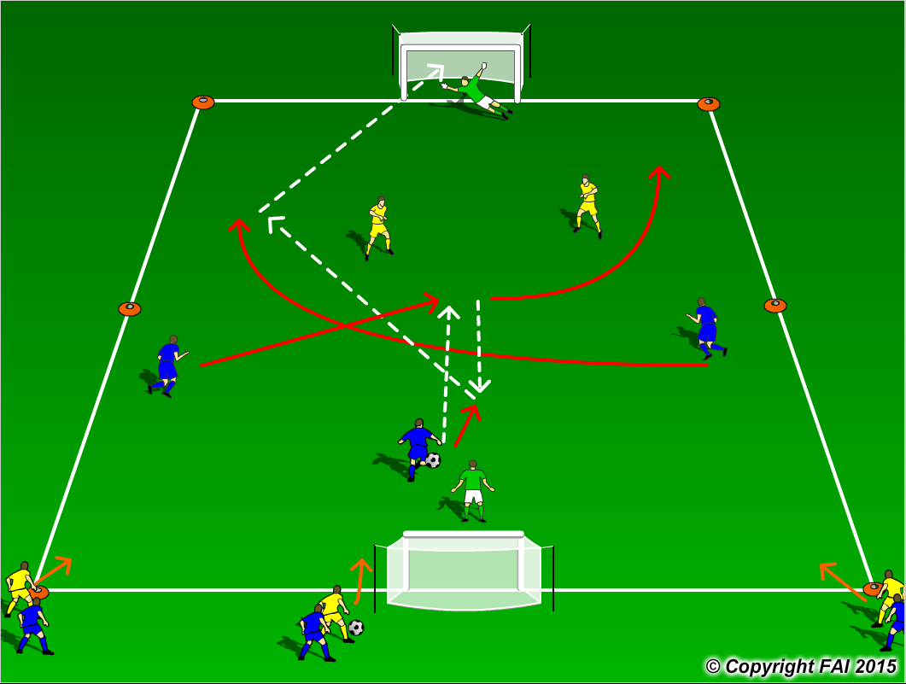

ORGANISATION
- Area: 40 x 30 metres
- 3 Blues v 2 Yellows + 2 Goalkeepers. Both Blue and Yellow resting players at the same end as seen in diagram
- 3 Blue players start game against 2 Yellow players and try to create a goal scoring opportunity as seen above
- If Yellow team win the ball they transition to attack the opposite goal
- If a goal is scored or the the ball leaves the pitch – the Blue team must quickly transition to defend with two players staying on the pitch while 3 new Yellow players now attack
- Have a supply of footballs on the side to keep the practice at a high intensity

KEY FACTORS
- Attacking: Look for players to spread out in possession and make the pitch as big as possible
- Encourage players to play with their head up and check shoulder so they can find the free player and be aware of pressure from opposition
- Angles and distance of support, can the player on the ball pass to you?
- Defending: Can defenders delay 3 attackers in making decisions – press and cover
- Transition to attack – counter attacks
- Quick transition from 3 v 2 into 2 v 3 is important…concentration is vital
- Communication and awareness is key

NOTES
Let the game flow freely, not too much stops, let the players solve the problems. Demand high intensity – give team time limits when on counter attack

