THEME
Speed development with the ball 2 v 2

DESCRIPTION OF PRACTICE (TECHNIQUE / SKILL)
A practice designed to improve players speed and speed of thought in a game related practice with transition

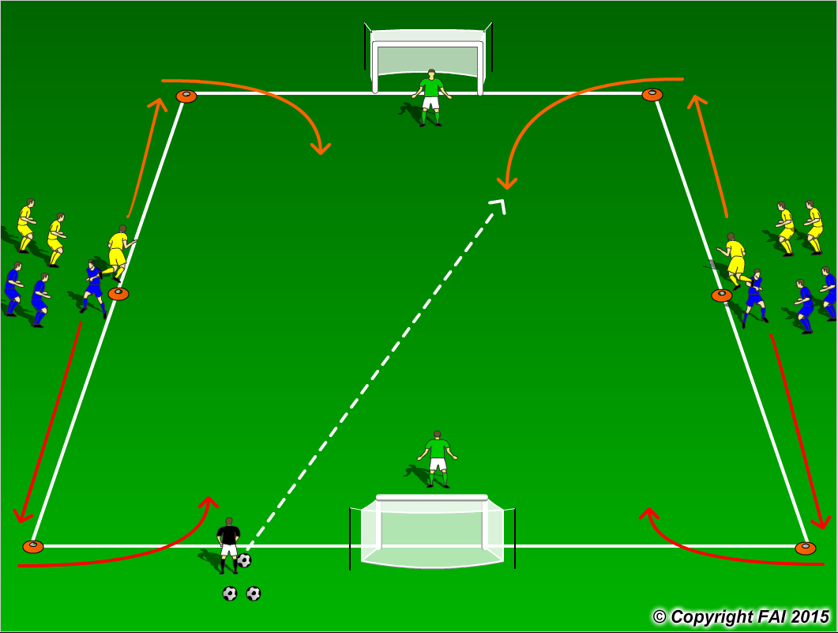

ORGANISATION
- Area: 25x20 metres
- 6 Blues and 6 Yellows + 2 Goalkeepers
- Divide players into two groups with the middle cone as the starting point, as seen above
- On the coaches signal the players sprint to opposite end cones, coach gives the ball to the first player into the area
- Players play 2v2 until one team scores or the ball goes out of play
- On coaches call GK’s sprint to opposite goal
- Have a supply of footballs to keep the practice continually flowing

KEY FACTORS
- Straight line run – technique of running – head straight, arms close to body, shoulders relaxed, balls of foot touches the ground
- Acceleration and Deceleration – both equally important
- Change of direction – turn quickly in small space, quick feet
- Quick decision making
- Ratio work to rest 1:5
- 100% effort with and without the ball
- Quick transition in both attack and defence

NOTES
Watch each players running technique, look to correct mistakes. Two coaches one plays in ball, second addresses any running technique issues. If players of good ability, give teams time limit to score when in possession

