THEME
1 v 1 Movement To Create Space

DESCRIPTION OF PRACTICE (TECHNIQUE / SKILL)
A functional practice designed to improve players 1 v 1 ability in movement to create space, turning, dribbling and finishing with transition to defend

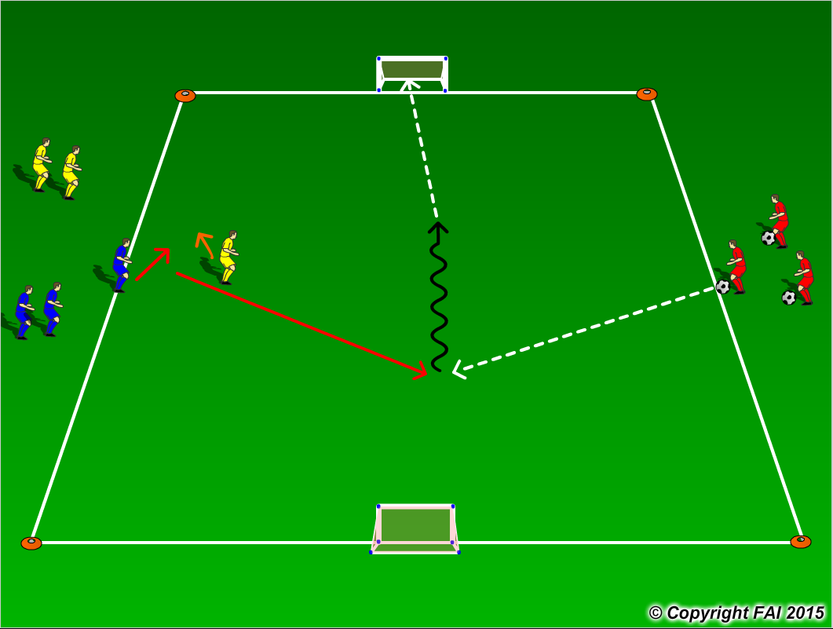

ORGANISATION
- Area 20 x 15 metres
- 1 Blue (attacker) v 1 Yellow (defender) with 1 Red acting as server
- Blue player starts behind Yellow player and must create space through movement to receive pass from Red player
- On receiving the ball, can the Blue player now dribble towards goal and finishing
- If Yellow player wins the ball, he/she can score in the opposite goal with the Blue player now transitioning to defend
- This process continues until all attackers have completed the cycle, the coach then rotates the players
- Red players to have supply of footballs to keep the practice continually flowing

KEY FACTORS
- Quick awareness and movement to escape defender
- Can player change direction (feints/disguises) to beat defender
- Quick acceleration while dribbling
- Finishing
- If ball is lost quick transition to defend

NOTES
Make sure that players play till goal is scored, i.e. goal is scored or ball goes out of play, and are aware of the transitions. If players of good quality give them time limit to score

