THEME
Speed development With The Ball – Speed and Decision Making Square

DESCRIPTION OF PRACTICE (TECHNIQUE / SKILL)
A practice designed to improve players speed and decision making

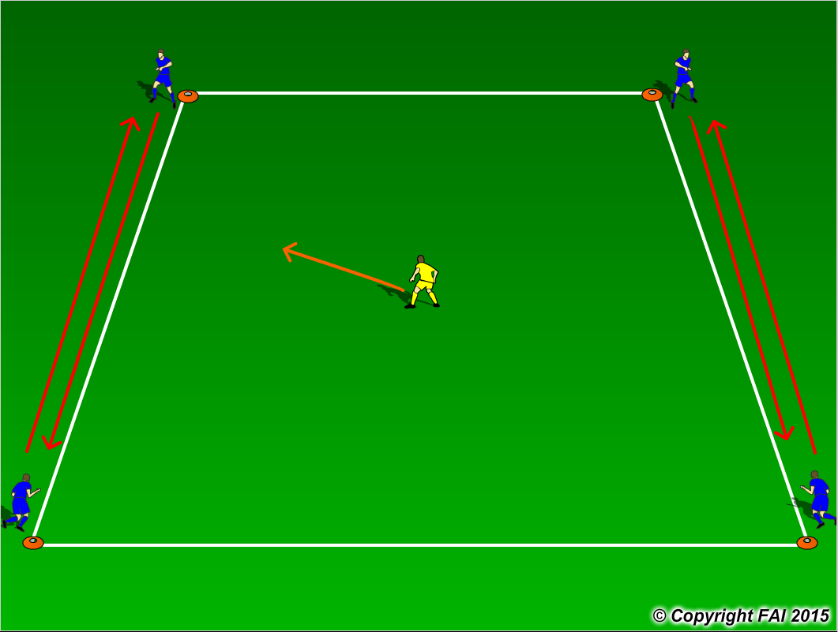

ORGANISATION
- Area: 12 x12 metres
- 4 Blues on each cone, 1 yellow player in the middle of the area
- Blue players must switch between cones (vertical, horizontal or diagonal), but there can only be one Blue player on each cone
- Yellow player tries to tag any of the Blue players before they get to the cone, if successful they then switch and the tagged player goes in the middle
- Can progress to Blue players having a football each, where they now must dribble

KEY FACTORS
- Straight line run – technique of running – head straight, arms close to body, shoulders relaxed, balls of foot touches the ground
- Acceleration and Deceleration – both equally important
- Change of direction – turn quickly in small space, quick feet
- 100% effort with and without the ball
- Decision making, when to go, can we switch when the Yellow player is on his/her blindside

NOTES
Get the middle player to just to hold a bib so there is a quick turn over. Only play for 5-8 minutes max, Quality rather than Quantity.

