THEME
6 v 5 Underload Defending with Transition

DESCRIPTION OF PRACTICE (TECHNIQUE / SKILL)
A functional practice designed to improve players Defensive shape as a unit – Pressure, Cover and Balance with Transition

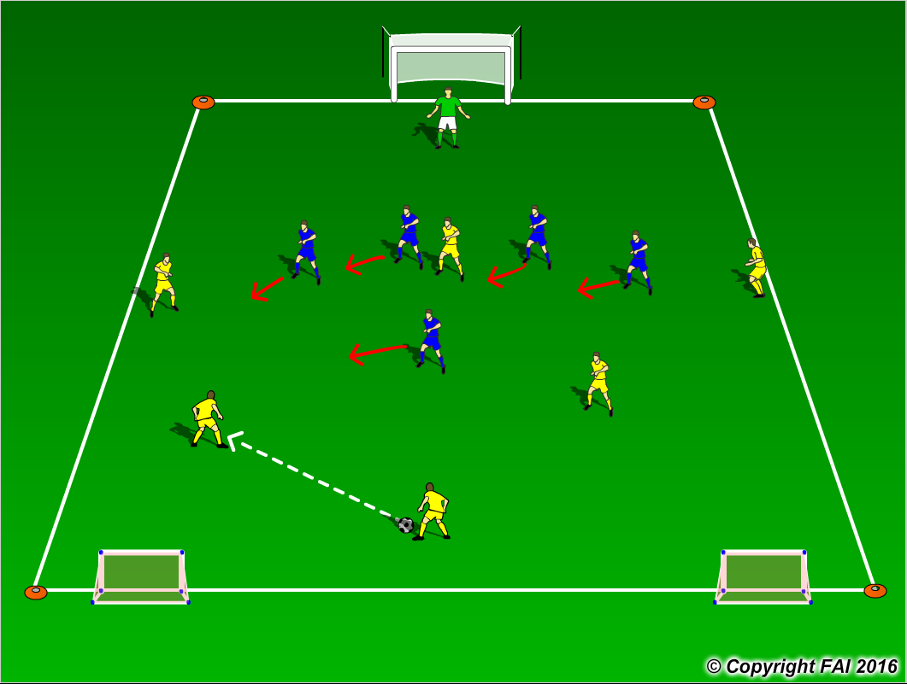

ORGANISATION
- Area: 40 metres x 30 metres
- 5 Blue players v 6 Yellow players + Goalkeeper
- Blue Team: Goalkeeper, Back 4 (RB, CB, CB & LB) and one Holding Midfielder
- Yellow Team: Midfield 3, one Holding Midfielder (6) and 2 Advanced Midfielders (8 & 10) and Attacking 3(CF, WR & WL)
- Yellow team start the practice with emphasis on creating goal scoring opportunities against the Blue team. Blue team look to maintain shape and balance throughout attempting to close space off through the middle.
- If the Blue team win possession they must quickly Transition to Attack and attempt to score in either of the small goals with the Yellow team now Transitioning to Defend
- If the ball goes out of play, game restarts with Yellow team

KEY FACTORS
- Team Shape – narrow and compact – make it difficult to play through
- Maintain shape and recognize when to press
- Communication between Defensive units is key! – Goalkeeper role very important!
- Limit space in between and behind the units
- Opened body shape when Defending see ball and man
- Look for pressing triggers, i.e. quality of pass, body shape of opponent, first touch
- When ball is won, look to play forward as quickly as possible through quality passing or dribbling

NOTES
1 v 1 Defending is key – Delay, Deny, Destroy. Encourage freedom and focus in Transition to Attack

