THEME
Defending with Midfield 3, Back 2 and Goalkeeper with transition to Attack

DESCRIPTION OF PRACTICE (TECHNIQUE / SKILL)
Phase of Play practice designed to improve Defending from the Midfield 3, Defenders and Goalkeeper based on a 7 v 7 Small Sided Game with formation 1.2.3.1

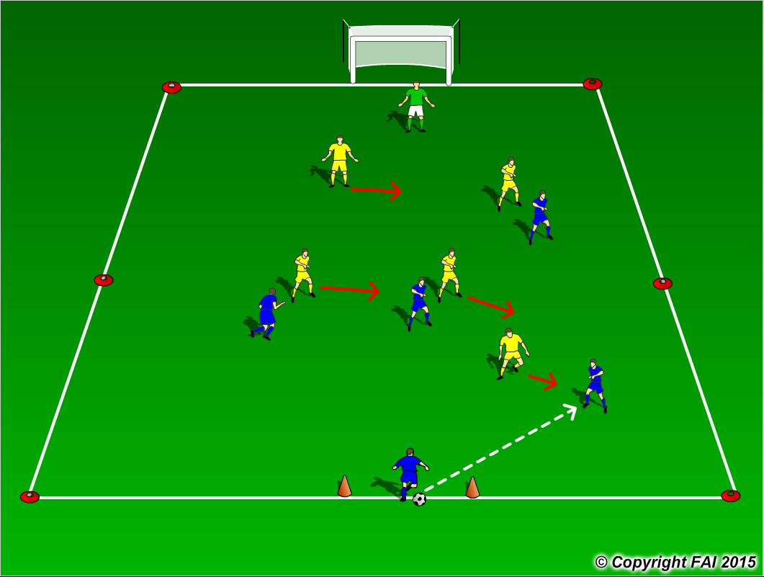

ORGANISATION
- Area: 40 metres x 35 metres
- In Yellow Goalkeeper, 2 Defenders + 3 Midfields V In Blue Striker + 3 Midfielders
- 1 Target Blue player standing in the gate
- Blue team play from the Blue player in the gate and try to score in the main goal, if the Yellow players win the ball they score by playing the ball to the Blue player in the gate
- If the Blue target player receives the ball, he can then join in and attack the main goal with the Blue team (This should be done as a progression to make it more difficult for Yellow team)

KEY FACTORS
- Starting Positions – narrow and compact, make it difficult for attacking team to play through passes. Two holding Midfielders (6 & 8) and one advanced Midfielder (10) for the Blue team
- Nearest player to the player on the ball presses (1 v 1 Defending)
- The rest of the team move in relation to this providing close cover and screening forward passes
- Communication from players behind is key
- Opened body shape when defending see the ball and man
- Goalkeeper role is crucial providing communication and cover for the ball over the top (Keeper/Sweeper)
- When ball is won, look to play forward as quickly as possible through quality passing.

NOTES
100% concentration needed, communication between players is vital.

