THEME
Attacking with Goalkeeper, Back 2 and Midfield 3 with transition to defend

DESCRIPTION OF PRACTICE (TECHNIQUE / SKILL)
Phase of Play practice designed to improve players technique and tactical awareness when playing out from the back based on a 7 v 7 Small Sided Game with formation 1.2.3.1

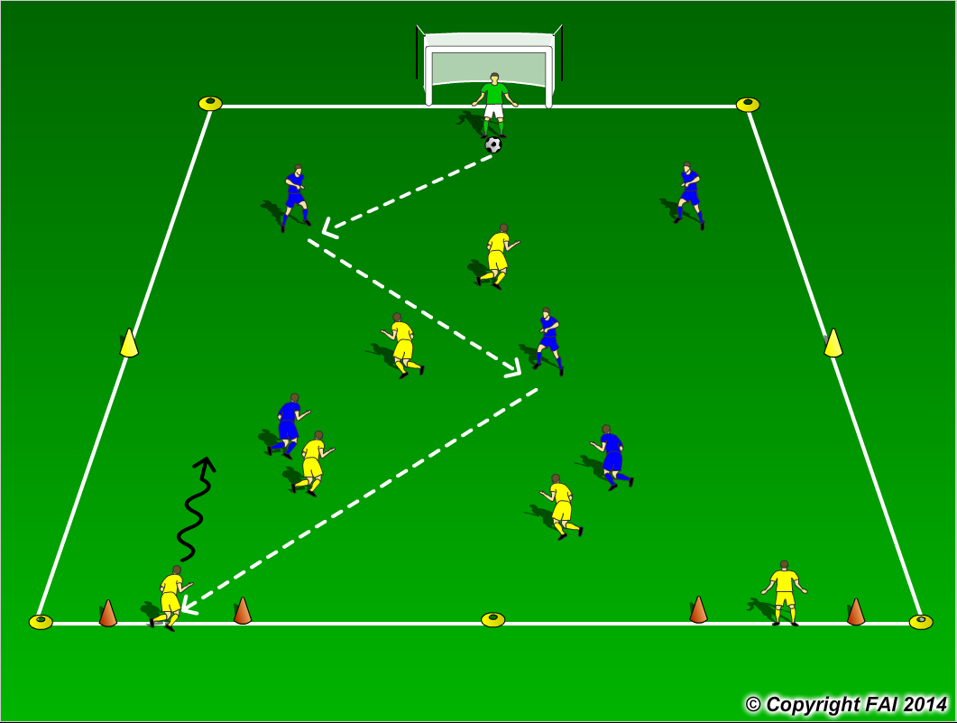

ORGANISATION
- Area: 40 metres x 35 metres
- In Blue Goalkeeper + 2 Defenders + 3 Midfielders V in Yellow 3 Midfielders + 1 Forward
- 2 Target Yellow players standing in the gates
- Goalkeeper starts the play at all times with the ball in the middle of 6 yard box
- Blue team looking to build from the back and score through any of 2 gates to Yellow players that then attack Blue goal, Blues must quickly transition to defend

KEY FACTORS
- Starting positions of Defenders – wide and high, open body shape, awareness and receive on back foot
- Midfield with Holding Midfielder (6) and 2 advanced Midfielders (8 & 10)
- Quality and selection of pass
- First touch and body shape (opened looking to play forward)
- Angles and distance of support
- Awareness and communication
- Transition to defend if ball is lost, can they win it back as quickly as possible (Pressing as a unit)

NOTES
Goalkeeper’s role very important, Quality of passing and decision making crucial. Look for high tempo

