THEME
Attacking with Goalkeeper, 2 Defenders and 1 Midfielder with transition to defend

DESCRIPTION OF PRACTICE (TECHNIQUE / SKILL)
A functional practice designed to improve players Technique and Tactical Awareness when playing out from the back

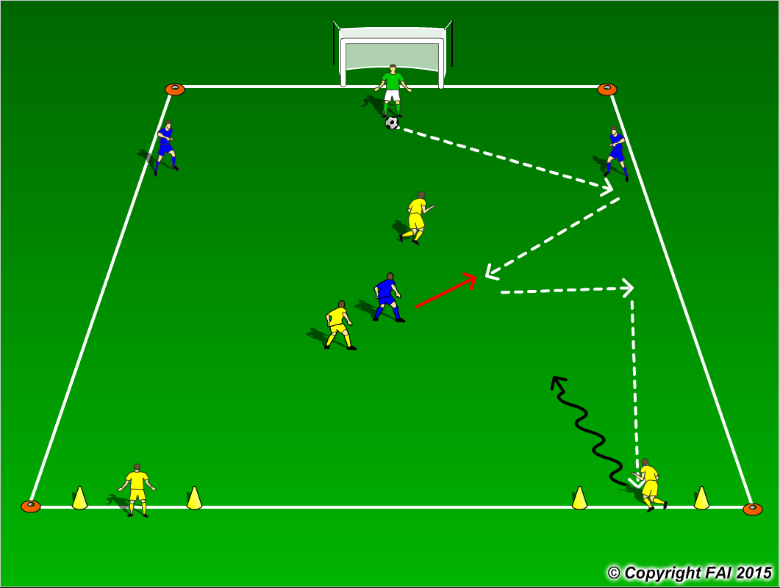

ORGANISATION
- Area: 30 x 25 metres and 2 Gates positioned at opposite end
- In Blue: 1 Goalkeeper + 2 Defenders + 1 Midfielder v in Yellow: 1 Midfielder + 1 Forward
- 2 Target Yellow players standing in the gates
- Goalkeeper starts the play at all times with the ball in the middle of 6 yard box
- Blue Team looking to build from the back and score through any of 2 gates to Yellow players that then attack Blue goal, Blue Team must quickly transition to defend

KEY FACTORS
- Starting positions of Center Backs – edge of area creating width and space
- Midfield player starting centrally
- Quality and selection of pass
- First touch and body shape (opened looking to play forward)
- Angles and distance of support
- Awareness and communication
- Transition to defend, if Blue Team lose the ball in build up, can they win it back as quickly as possible (Pressing)

NOTES
Get the Yellow Team to drop off and put on limited pressure at the start to get the Blue Team comfortable in possession. Goalkeeper’s role very important, Quality of passing and decision making crucial

