THEME
4 v 4 Defending with Transition

DESCRIPTION OF PRACTICE (TECHNIQUE / SKILL)
A functional practice designed to improve players Defending as a unit – Pressure, Cover and Balance

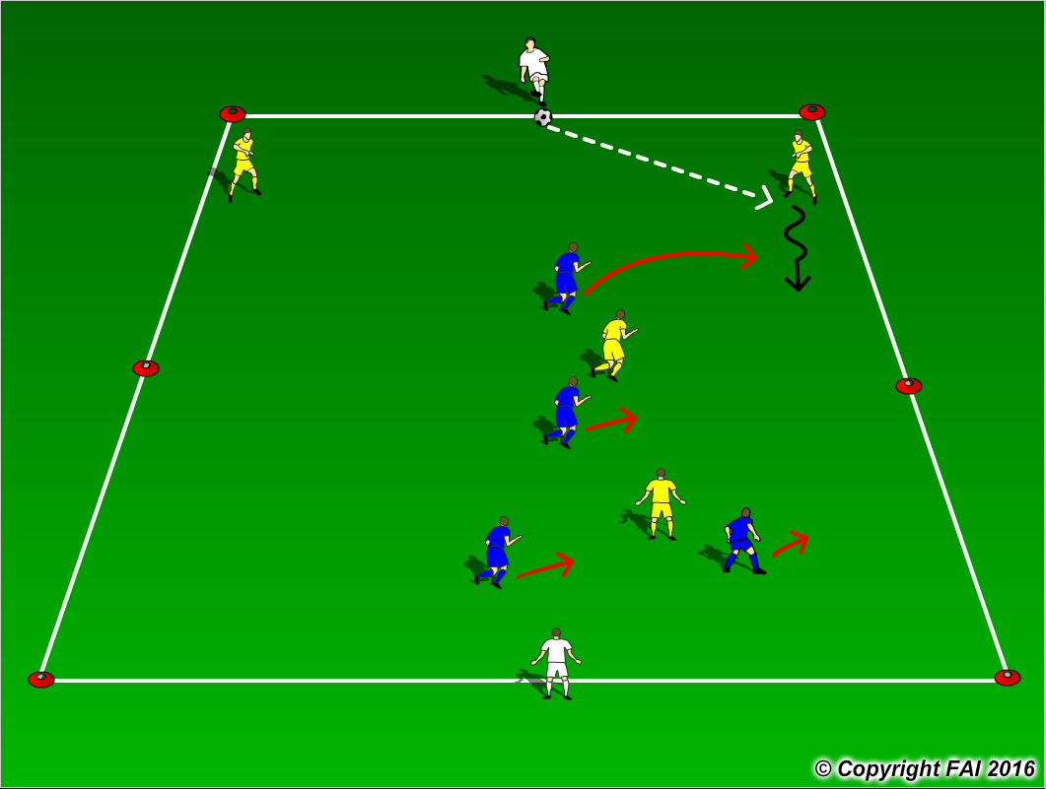

ORGANISATION
- Area: 30 metres x 20 metres
- 4 v 4 inside the area, formation for both teams (Yellow and Blue players) 2 Defenders, 1 Midfielder, 1 Center Forward with 2 White target players, 1 at each end
- White players cannot be tackled and can move along the end line to receive a pass
- Yellow players play to one end (as per diagram) White player that receives, passes the ball into Blue players, Blue players must then looks to play to the other to the opposite White player
- If the ball goes out of play, game restarts with a kick in from opposite team

KEY FACTORS
- Team Shape – narrow and compact – make it difficult to play through
- As Defender moves forward in possession Center Forward makes a curved run to cut off a pass to Second Defender (Pressure)
- The rest of the team move in relation to this trapping the ball on one side of the pitch (Cover and Balance)
- Communication from players behind is key
- Opened body shape when Defending see ball and man
- When ball is won, look to play forward as quickly as possible through quality passing

NOTES
1 v 1 Defending is key – Delay, Deny, Destroy

