THEME
2 v 2 Defending with Transition

DESCRIPTION OF PRACTICE (TECHNIQUE / SKILL)
A functional practice designed to improve players 2 v 2 Defending – Pressure and Cover

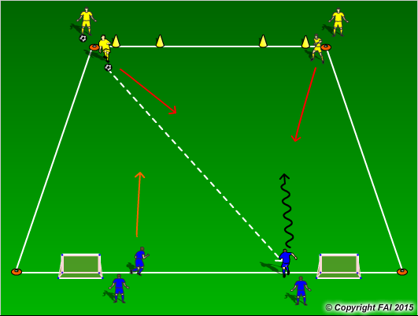

ORGANISATION
- Area 20 x 15 metres
- Yellow players (Defenders) pass the ball to the Blue players (Attackers) and Defend
- Blue players have to score by dribbling through either of the gates marked with cones, if the Yellow players win the ball they can score in either of the two small goals at the opposite end

KEY FACTORS
- Defenders react fast – get up quickly but under control in relation to goal
- Nearest Defender must press – as close as possible – stop forward play – 1 v 1 Defending stance
- Second Defender Covers – angles and distance – see your Attacker and the ball
- Changing roles as ball is passed – in/out
- Decision making and communication are vital
- If ball is won Transition to Attack

NOTES
Make sure that players play till goal is scored or ball goes out of play and are aware of the Transitions

