THEME
4 v 2 Possession into 2 v 1 Attack with Transition

DESCRIPTION OF PRACTICE (TECHNIQUE / SKILL)
A functional practice designed to improve players passing, movement, decision making and 2 v 1 Attacking

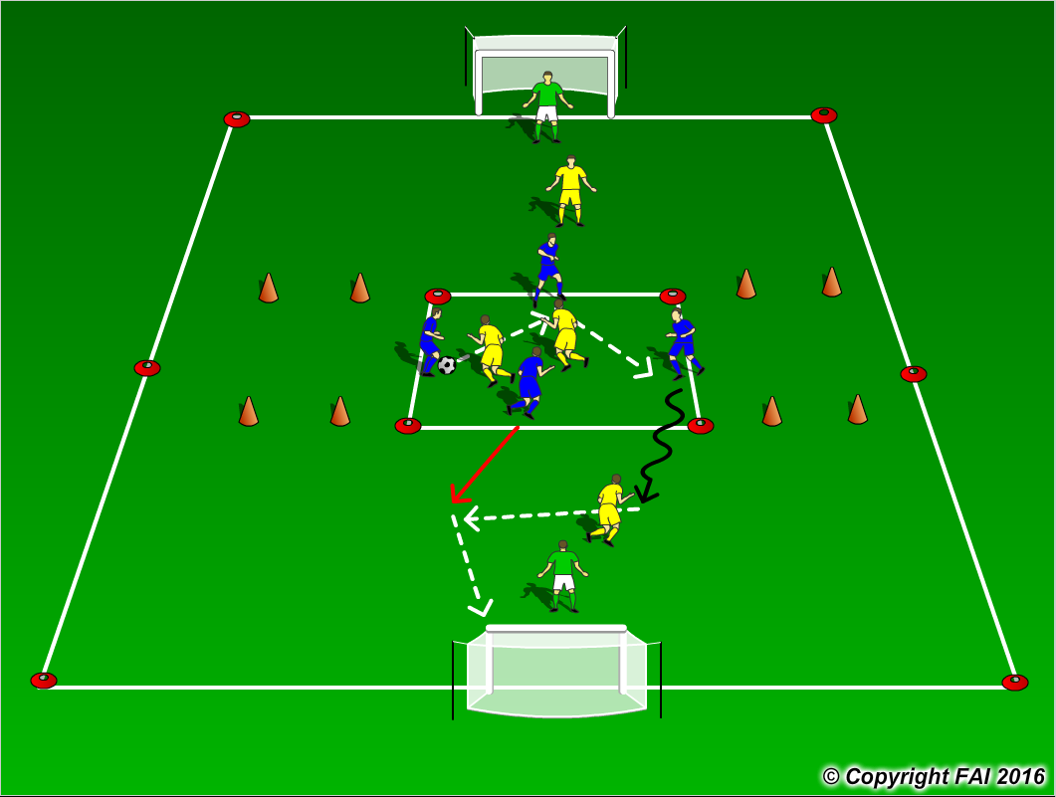

ORGANISATION
- Area: Pitch - 55 x 35 metres, 4 v 2 - 15 x 15 metres
- 4 Blue Players v 2 Yellow Players, after a set number of passes one Blue Player can dribble out of the area with one Blue Player to attack either goal to create a 2 v 1 with another Yellow Player, with 1 Goalkeeper in each goal
- If the Yellow player wins the ball in the 4 v 2 can they play to Yellow player outside to score in the goals marked with Red cones, one Blue player can leave the area to try and stop this
- If a Yellow player wins or Goalkeeper saves the football in the 2 v 1 can they also Transition to Attack and score through either of the goals marked with Red cones

KEY FACTORS
4 v 2 Possession
- Quality and selection of pass
- Body shape/First Touch/Back Foot
- Disguise/Change of Direction
- Angles and Distance of support
- Awareness of space and defender
2 v 1 Attack
- Positive first touch, get the ball out of your feet, Attack the defender with the ball under control
- Keep your head up to assess defenders position and see support player
- Decision making – pass or disguise, also look for overlaps and wall passes

NOTES
Keep scores and rotate groups so both get a chance to Attack and Defend

