THEME
8 v 4 Possession with 4 Goals

DESCRIPTION OF PRACTICE (TECHNIQUE / SKILL)
A practice designed to improve players ability to keep possession and also Improve players pressing as a team and finishing

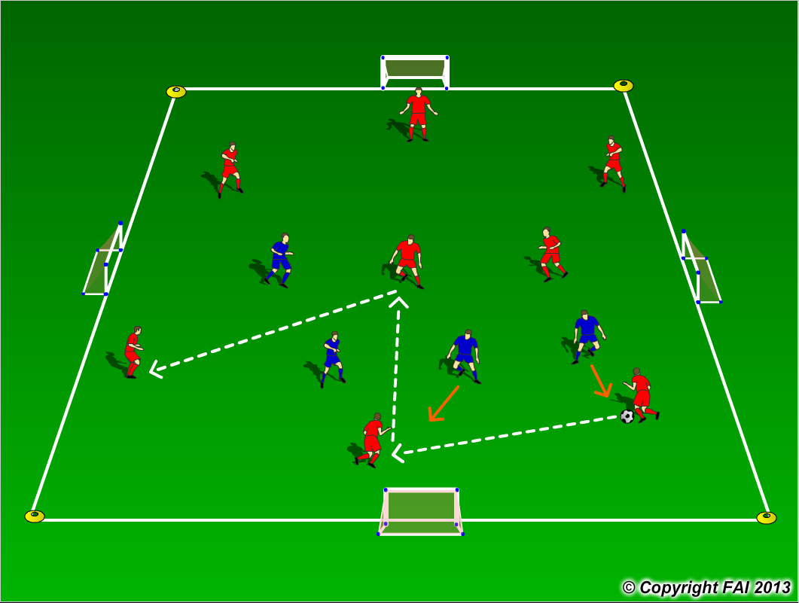

ORGANISATION
- Area 30 x 30 metres
- 8 v 4 - 8 Reds v 4 Blues with 4 small goals
- 8 Reds try to keep possession, the 4 Blues try to press as a team and win the ball back, when they win the ball back they must try and score in any of the 4 Goals

KEY FACTORS
RED TEAM
- Quality of pass – pace, weight and accuracy. Support – Angles and distance
- Individual movement to receive pass, open body shape, looking to play forward.
- Pass to feet or space? Let players make decisions
- Passing triangles – always at least two options for player on the ball
- Communication between players
BLUE TEAM
- Nearest man pressure, try to make play predictable – show them one way
- React from the movement of first pressing player, communicate as a team
- When ball is won back be clinical and finish as quickly as possible

NOTES
Look for high work rate from blue team, change the team of four every 3/4 minutes

