THEME
Passing and control - 2 touch

DESCRIPTION OF PRACTICE (TECHNIQUE / SKILL)
A practice to improve players passing and control

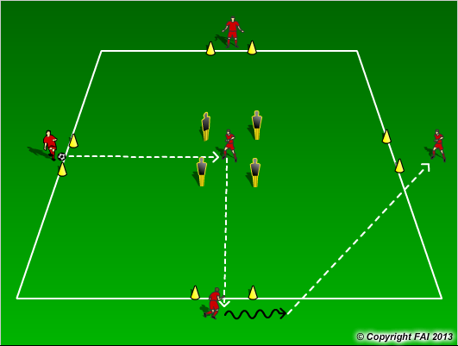

ORGANISATION
- Area: 20 x 20 metres, gates 1 metre
- 5 players as per diagram, use mannequins or cones for middle area
- Pass into middle player, with max two touch he plays it out to any of three other outside players, they play diagonal to another player and process starts again
- Rotate middle player every two minutes, can play competition middle player get point for two touch play and scoring through outside gates.

KEY FACTORS
- Quality of the pass – accuracy, pace, weight
- Open body shape
- Know what your next pass is early
- One or two touch - players make decisions
- Communication

NOTES
High tempo, no sloppy passes, introduce competition to increase motivation

