THEME
5 v 5 Small Sided Game – Possession

DESCRIPTION OF PRACTICE (TECHNIQUE / SKILL)
A Small Sided Game practice designed to improve players passing, control and decision making with an emphasis on keeping possession with a purpose

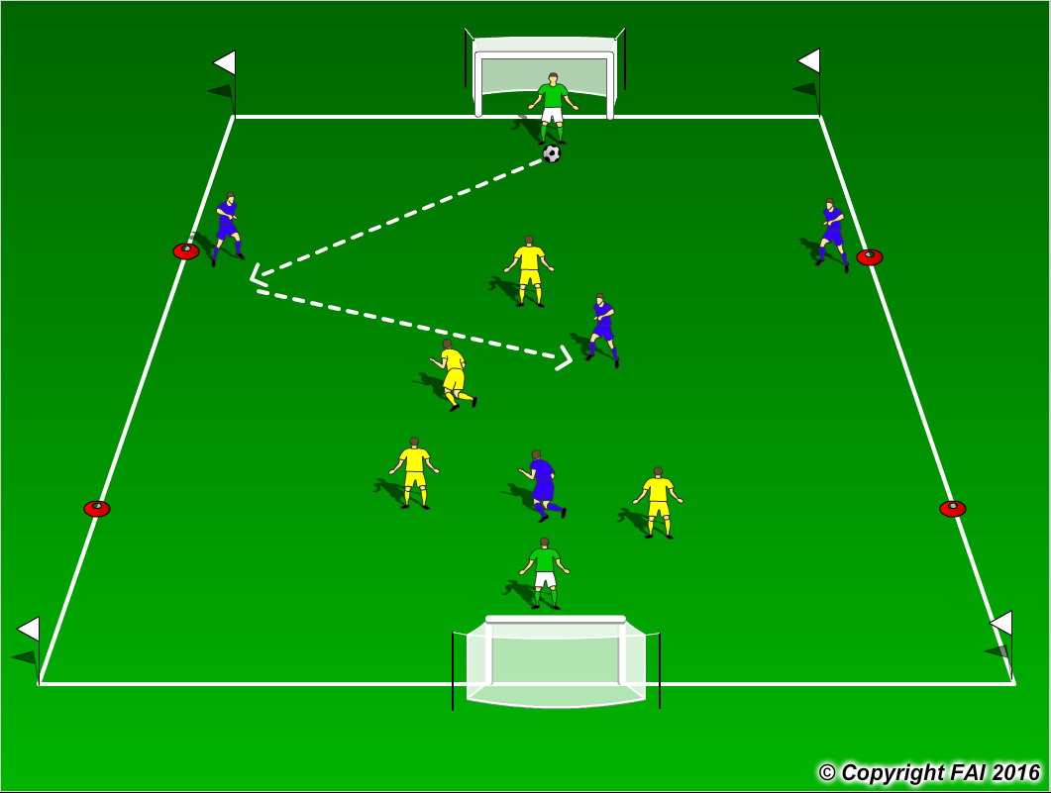

ORGANISATION
- Area : 40 x 30 metres
- Offsides in the attacking thirds
- Formation – 1 Goalkeeper, 2 Defenders, 1 Midfielder and 1 Striker on both teams
- No Corners, Kick in’s when ball leaves play
- Supply of footballs in each goal

KEY FACTORS
- Team Shape – Width and Depth
- Quality of pass (Accuracy, weight, timing and disguise)
- Opened Body shape/First Touch/Back Foot
- Support for man on the ball (Angles, Distance and Communication)
- Selection of Pass (Penetrate or Possession)
- End Product

NOTES
Start game with free play before starting to coach, Coach one team during the practice but look for the other team to replicate

