THEME
1 v 1 Change of Direction

DESCRIPTION OF PRACTICE (TECHNIQUE / SKILL)
A functional practice designed to improve players 1 v 1 dribbling and change of direction with transition to defend
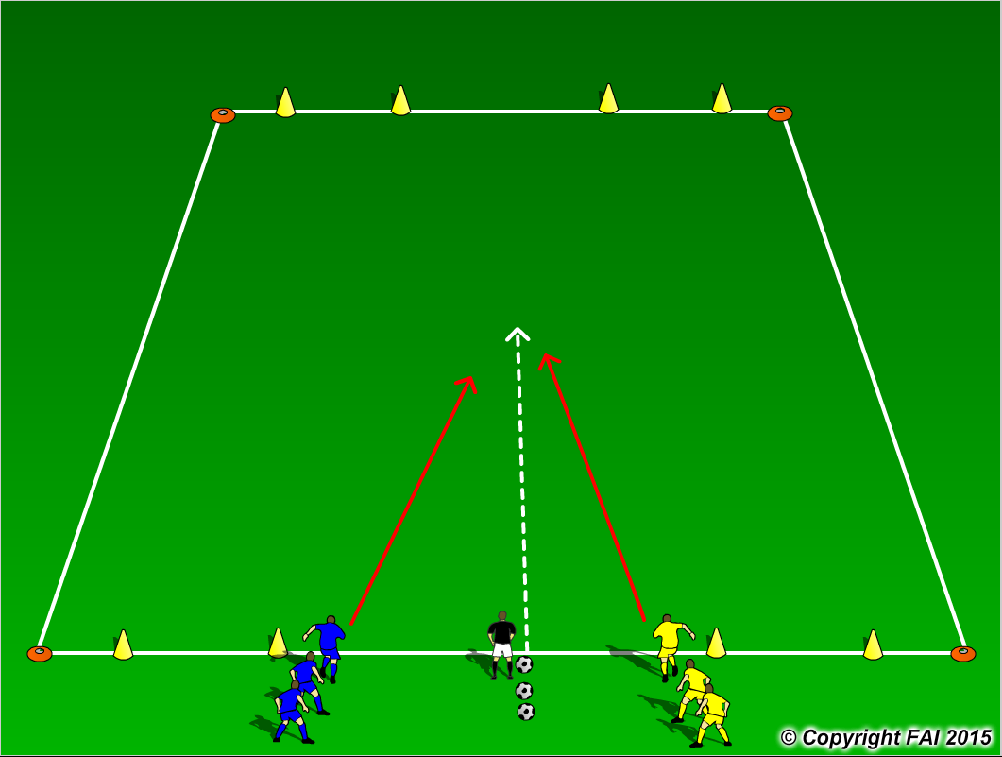
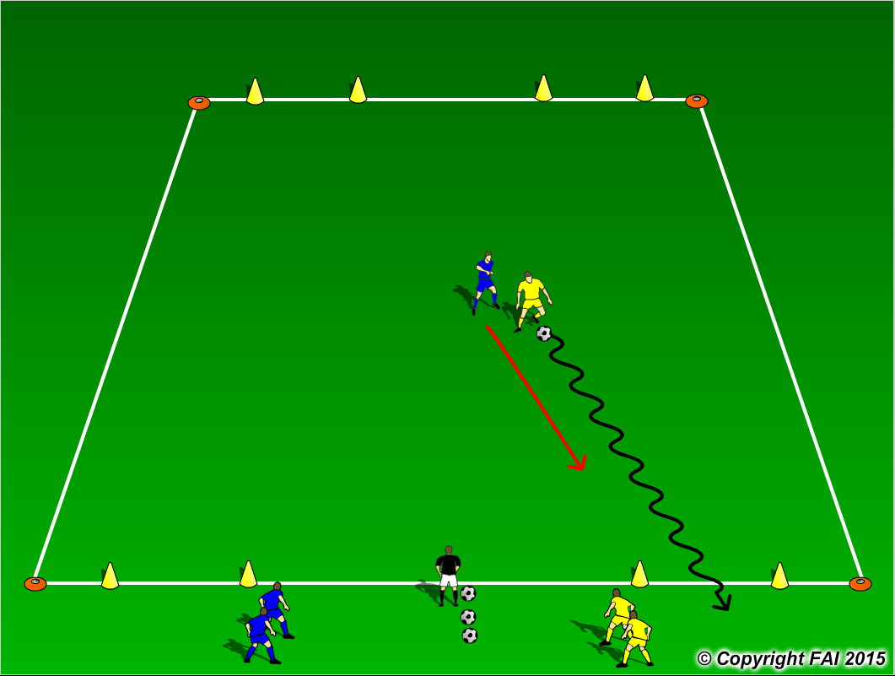

ORGANISATION
- Area 20 x 15 metres
- Blue and Yellow players both start as attackers either side of the coach. When the coach passes the ball into the area both the Blue and Yellow players run to win the ball as seen in diagram 1. When player wins the ball they must change direction and dribble through either goal at the end that they started from as seen in diagram 2, if in this case the Blue player wins the ball he/she changes direction and tries to dribble through either of the small cones at the other end

KEY FACTORS
- Standing start, players to have forward lean when they move
- Quick acceleration
- Can player change direction with the ball under control from pressure
- Make your move (Skill, trick or speed)
- Accelerate into space created
- If ball is lost quick transition to defend

NOTES
Make sure that players play till goal is scored, i.e. dribble through either goal, or ball goes out of play and are aware of the transitions. If players of good quality give them time limit to score

