THEME
2v2+5 Bumper Possession

DESCRIPTION OF PRACTICE (TECHNIQUE / SKILL)
A Practice designed to improve players passing, angles , movement and finishing with transition to defend

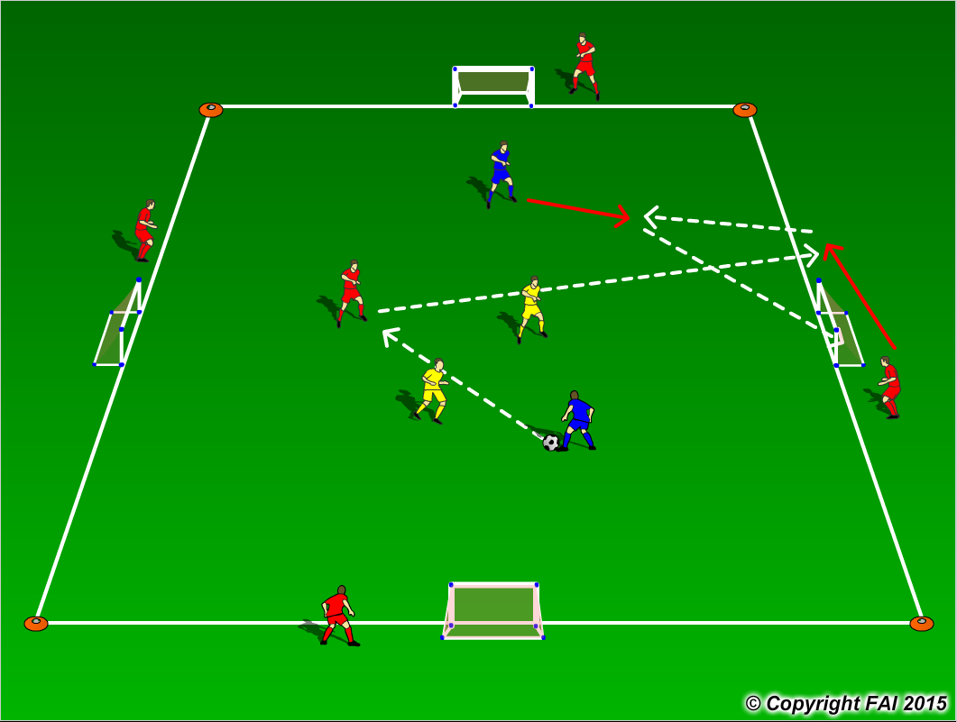

ORGANISATION
- Area: 16 x16 metres
- 2 Blues v 2 Yellows + 5 Red (neutral player)
- 2v2+1 inside the area with bumper players on the outside that move freely up and down along their end line area.
- In order to score, team in possession must use their end line bumper player.
- The neutral player can’t score and plays only for team in possession
- Bumper players and neutral player start play with two touch, encourage to play one touch
- Outside bumper players to switch every 2 minutes
- If team scores, game restarts with opposite team
- Have a supply of footballs to keep the practice continually flowing

KEY FACTORS
- Quality and selection of pass – Back Foot
- First touch/Body shape
- Angles and Distance of support
- Width and depth – Penetrating Pass
- Awareness of space and defender
- Communication and Movement
- Finishing
- Transition to Defend – can we win ball back as quickly as possible
- Transition to Attack – width and depth as quickly as possible

NOTES
Demand high intensity. If players of a high ability play one touch

