THEME
4 v 2 + 1 Possession with Transition

DESCRIPTION OF PRACTICE (TECHNIQUE / SKILL)
A functional practice designed to improve players ability in possession and transfer of possession with Transition to Defend

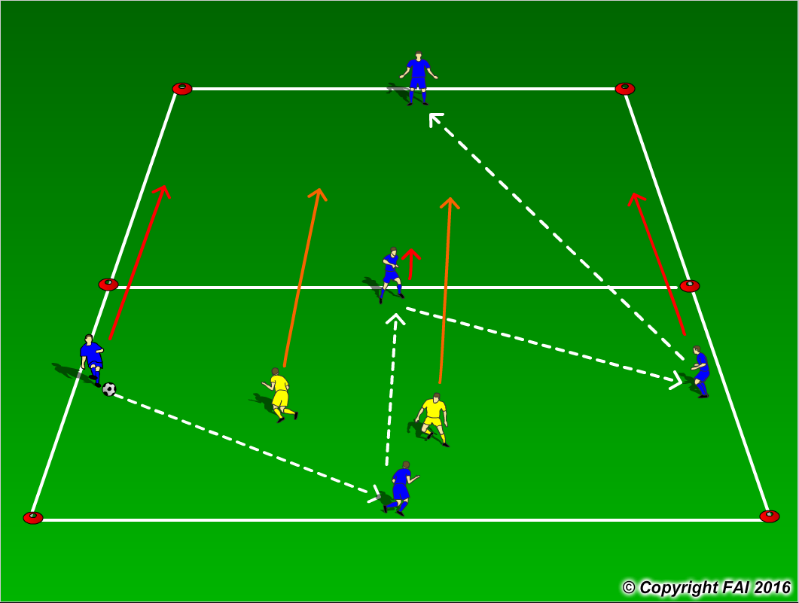

ORGANISATION
- Area: 24 x 12 metres
- 4 Blue players v 2 Yellow players start in one zone with 1 Blue player in the other zone
- 4 Blue players v 2 Yellow players start the practice, the Blue players must establish possession before transferring the ball (i.e. 5 passes)
- When the ball is transferred 3 Blue players now transfer to the other zone with the two Yellow players following them
- If a Yellow player wins the ball he/she must dribble outside the grid while the 4 players in possession must now quickly Transition to Defend
- Rotate Yellow Players after they dribble out of area or after 2 minutes

KEY FACTORS
- Create space (by individual & team mobility)
- Weight, accuracy and height of pass
- First touch/Body shape
- Angles and Distance of support
- Width and depth – Penetrating Pass
- Communication
- Awareness of space - defender
- Transition to Defend – can we win ball back as quickly as possible

NOTES
Demand high quality and tempo. If players of a high ability play two touch

