THEME
Transitional Rondo

DESCRIPTION OF PRACTICE (TECHNIQUE / SKILL)
A Practice designed to improve players ability in passing, movement and awareness with transition to defend

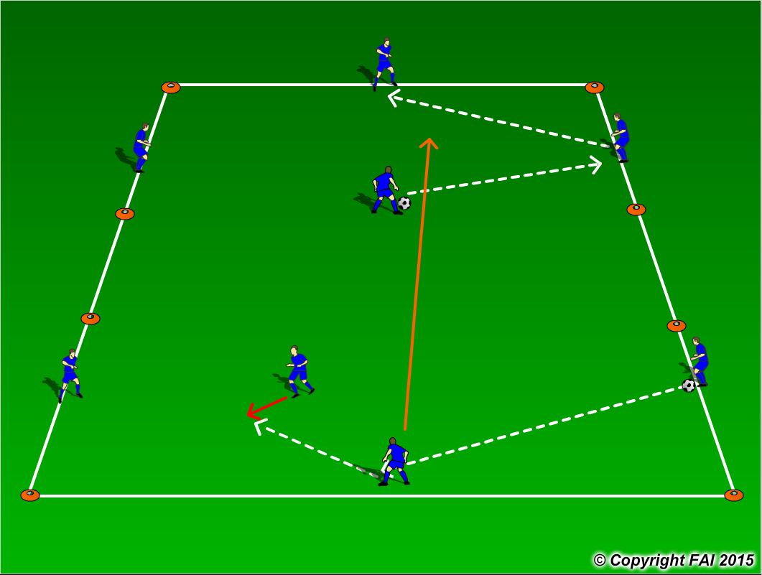

ORGANISATION
- Area: 2 x (12x12m) grids – 8m between both areas
- 4 Blues in each end grid
- Practice starts with one grid playing 3v1 while in the other grid the 4 players pass the ball to one another, (can this be done with one touch)?
- When the defender wins, the player who lost the ball must now transition to defend in the other grid as seen above and now the player that won the ball joins the other 2 players and pass the ball until a transition occurs
- Continue this cycle
- All players to wear same bib – this is done for the awareness of players
- Have a supply of footballs for the continuity of the practice

KEY FACTORS
- Create space (by individual & team mobility)
- First touch/Body shape
- Angles and Distance of support
- Weight of pass
- Communication
- Awareness of space /defender – can players see the oncoming defender?
- Transition to defend – can we win ball back as quickly as possible.
- Encourage defender in transitions – set the tempo

NOTES
Demand high quality and tempo. If players of a high ability play one/two touch

